TOURS and TRAVELS

**A Project Report Submitted**

**In Partial Fulfillment of the Requirements for the Degree of**

# MASTER OF COMPUTER APPLICATIONS

**by**

Kapil Kumar (1900290140018)

**Under the Supervision of**

**Ms. Neelam Rawat**

**KIET Group of Institutions, Ghaziabad**



**Submitted to**

**DEPARTMENT OF COMPUTER APPLICATION DR. APJ ABDUL KALAM TECHNICAL UNIVERSITY LUCKNOW**

**(Formerly Uttar Pradesh Technical University, Lucknow)**

**May 2022**

**DECLARATION**

I hereby declare that the work presented in this report entitled “**Tours and Travels**”, was carried out by me. I have not submitted the matter embodied in this report for the award of any other degree or diploma of any other University or Institute.

I have given due credit to the original authors/sources for all the words, ideas, diagrams, graphics, computer programs, experiments, results, that are not my original contribution. I have used quotation marks to identify verbatim sentences and given credit to the original authors/sources.

I affirm that no portion of my work is plagiarized, and the experiments and results reported in the report are not manipulated. In the event of a complaint of plagiarism and the manipulation of the experiments and results, I shall be fully responsible and answerable.

Name : Kapil Kumar Roll No. : 1900290140018

Branch : Master of Computer Application

**(Candidate Signature)**

**CERTIFICATE**

Certified that **Kapil Kumar**(**1900290140018**) has carried out the project work presented in this report entitled “**Tours and Travels**” for the award of **Master of Computer Application** from Dr. A.P.J. Abdul Kalam Technical University, Lucknow under my supervision. The report embodies result of original work, and studies are carried out by the student himself and the contents of the report do not form the basis for the award of any other degree to the candidate or to anybody else from this or any other University.

**Ms. Neelam Rawat External Examiner**

Associate Professor

Dept. of Computer Application

KIET Group of Institutions, Ghaziabad

**Dr. Ajay Kumar Shrivastava**

Professor & Head Department of Computer Application KIET Group of Institutions, Ghaziabad

Date: 22-05-2022

**Abstract**

The proposed project is an online tours and travels website that provides users with an easy way to plan their holiday packages online. The task sometimes becomes very tedious for the customers to search for their travelling modes and good hotels for their journey. This is a web- based application that overcomes the issue of finding and booking transport and hotels in everything in one place. One can book flights, cabs, buses, trains, hotels etc. through our website either by filling the booking form or by calling us. In this project we also have a feedback page, contact us & home page through which we can log in or register.

We are designing the Front-end using angular in which we have used HTML, CSS, Bootstrap and JavaScript.

**ACKNOWLEDGEMENTS**

I would like to express my special thanks of gratitude to my trainer **Mr. Vivek Kumar** as well as for her guidance, help and encouragement throughout my research work. Their enlightening ideas, comments, and suggestions.

My gratitude to my other office colleges and seniors, for here administrative help at various occasions. I am thankful to them.

Secondly, I would also thanks to my parents, teachers, and friends who me helped a lot in finishing this project within a limited time. Without their support, completion of this work would not have been possible in time. They keep my life filled with enjoyment and happiness.

**Kapil Kumar 1900290140018**

# Project Overview

Modules:- There are 12 different pages on our website.

1. Home
2. Log-in
3. Sign-up
4. Flight
5. Train
6. Bus
7. Cab
8. Hotel
9. Homestay
10. Contact Us
11. Feedback
12. About Us

# Objective

Our modern age of technology greatly depends on the internet. Everything is digital for easier and faster communication. Here we are trying to develop such a system, which will ensure some aspects,

* Reliability, maintainability, cost-effectiveness and a nice user-friendly environment.
* The objective of the project is to enable easier & much quicker transport booking.
* Proper management of bookings.
* Saving money and time

# Project Analysis

Initially, the user must log in if he has an account on our website or registers then log in. After that, he can choose the transport he wants to choose to get to a location. He can choose from bus, cab, train or flight. Each one has the option to choose from where to where the person wants to go. After that, he can choose which type of hotel he wants to stay in or does he want to be in a homestay. Customers can also provide feedback for our services and contact us via phone, mail or physically visit our office location.

# Project Planning

Proper project management is essential for the successful completion of a software project. Software project management (responsible for project planning) specifies activities necessary to complete the project. After this, a project schedule is prepared to accomplish the specified tasks. The purpose of planning and scheduling is to develop the software according to the user requirements within the allocated time and budget. Project planning is a part of project management, which relates to using a schedule such as charts to plan and report progress within the project environment.

* Select Project
* Identifying the project’s aims & objectives.
* Understanding requirements & specification
* Methods of analysis, design & implementation
* Testing techniques
* Budget allocation
* Project Estimation & deliverables
* Resources Allocation
* Risk Management

# Software and hardware requirements

1. **IDE use:** We are using the Visual Studio Code for running Angular in it and using node as the serve.
2. **Languages use:**
   * HTML: used for writing webpage or front end code.
   * CSS & Bootstrap: used for styling of webpages/front-end.
   * JavaScript: Used for form validations and prevention from entering invalid data.

# Serves/Database use:

* Node server: used for routing with the help of angular.

**List of Figures**

**Page no.**

Fig 1.1 Home 12

Fig 2.1 Log in 13

Fig 3.1 Sign up 14

Fig 4.1 Flights 15

Fig 5.1 Train 16

Fig 6.1 Buses 17

Fig 7.1 Cabs 18

Fig 8.1 Hotels 19

Fig 9.1 Home 20

Fig 10.1 Contact Us 21

Fig 11.1 Feedback 22

Fig 12.1 About Us 23

Fig 12.2 About Us 23

# Outputs

# 1 .Home

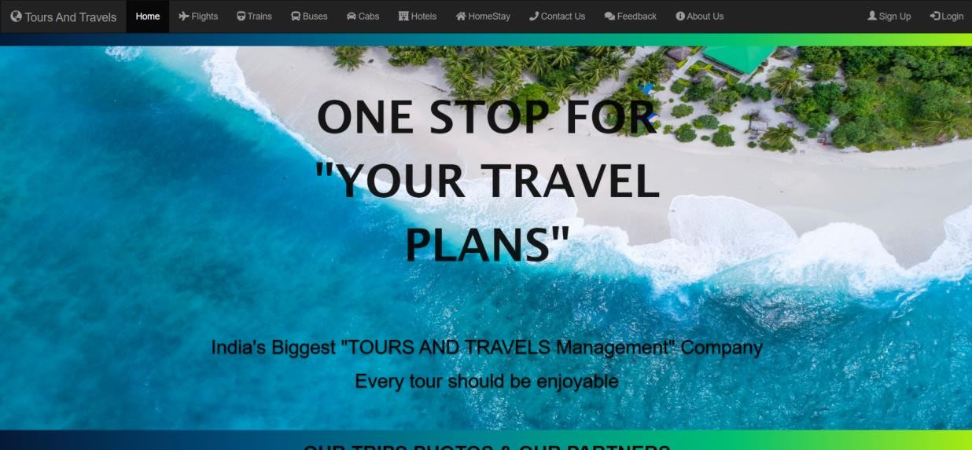

**Fig 1.1**

**2.Log-in**

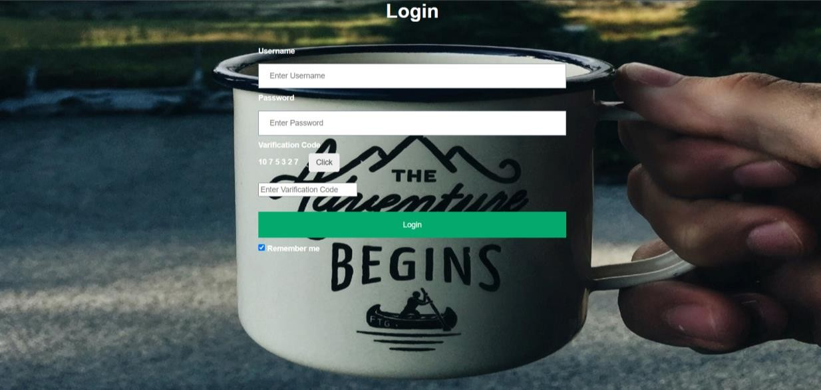

**Fig 2.1**

# 3.Sign-up

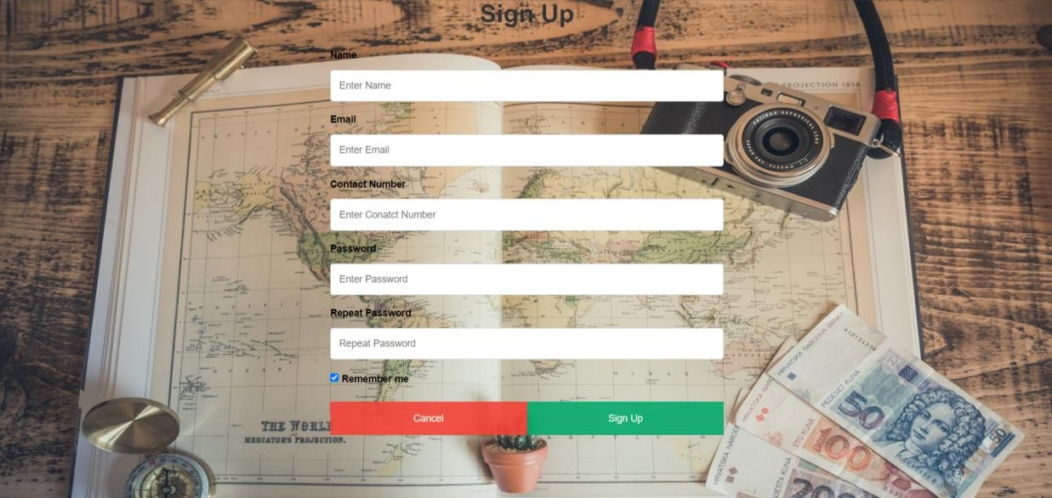

**Fig 3.1**

1. **Flights**

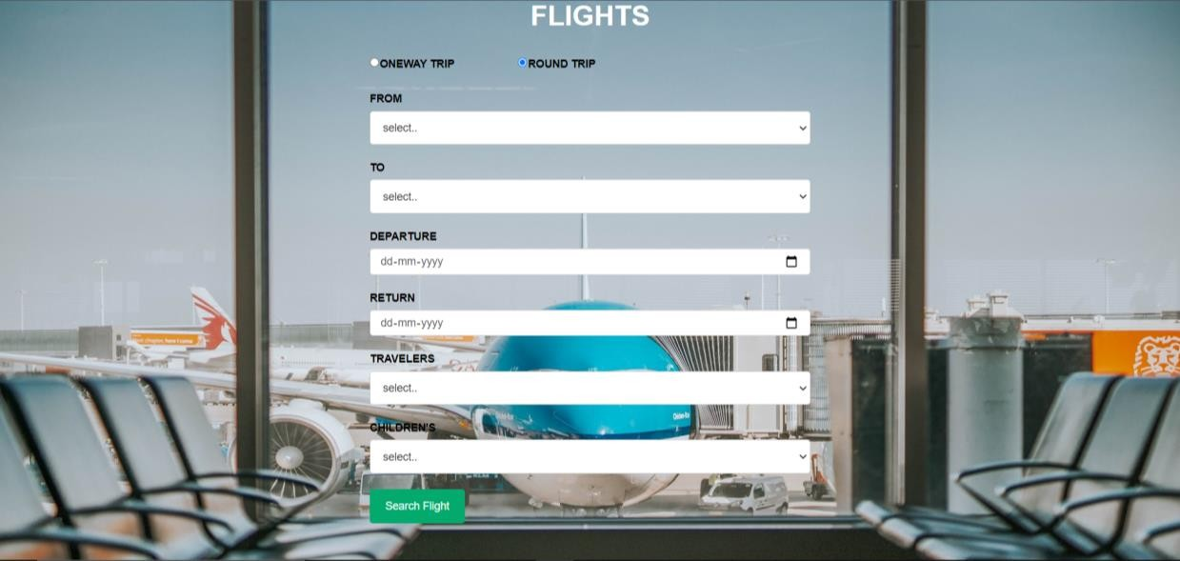

# Fig 4.1

# 5.Train

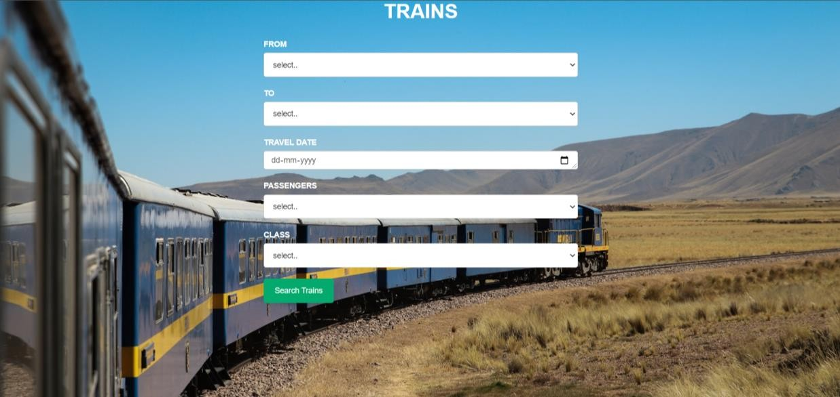

# Fig 5.1

1. **Buses**

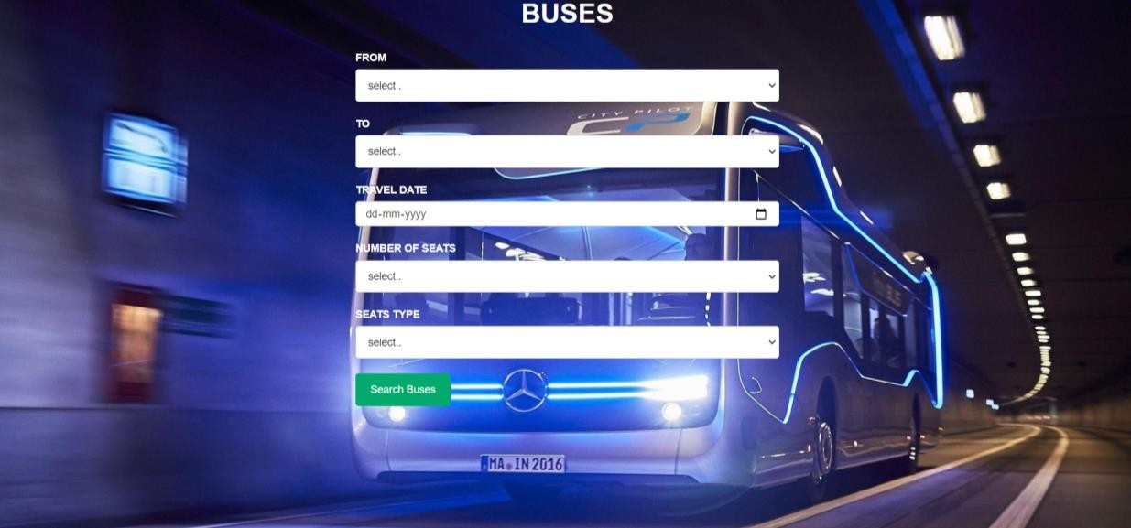

# Fig 6.1

# Cabs

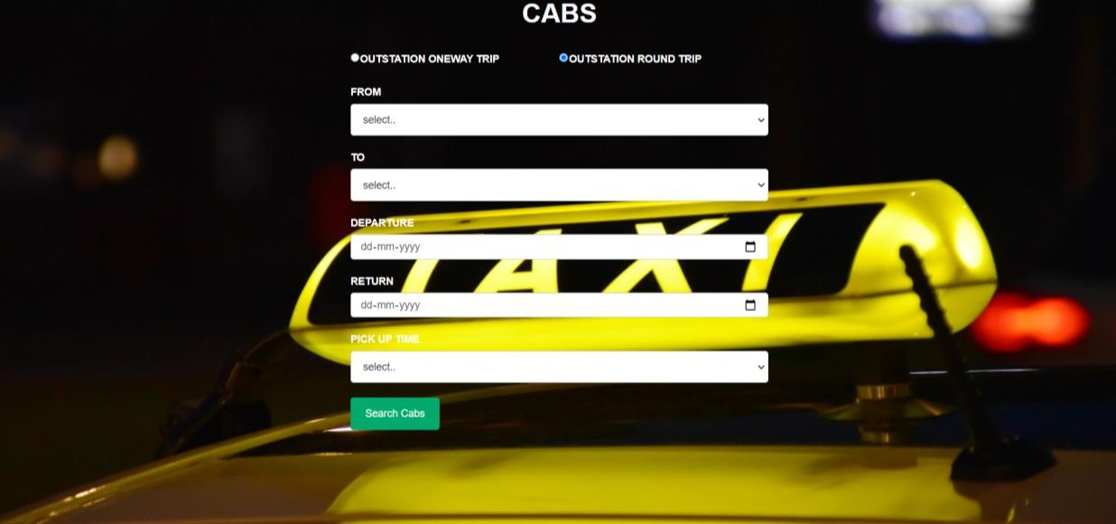

# Fig 7.1

1. **Hotels**

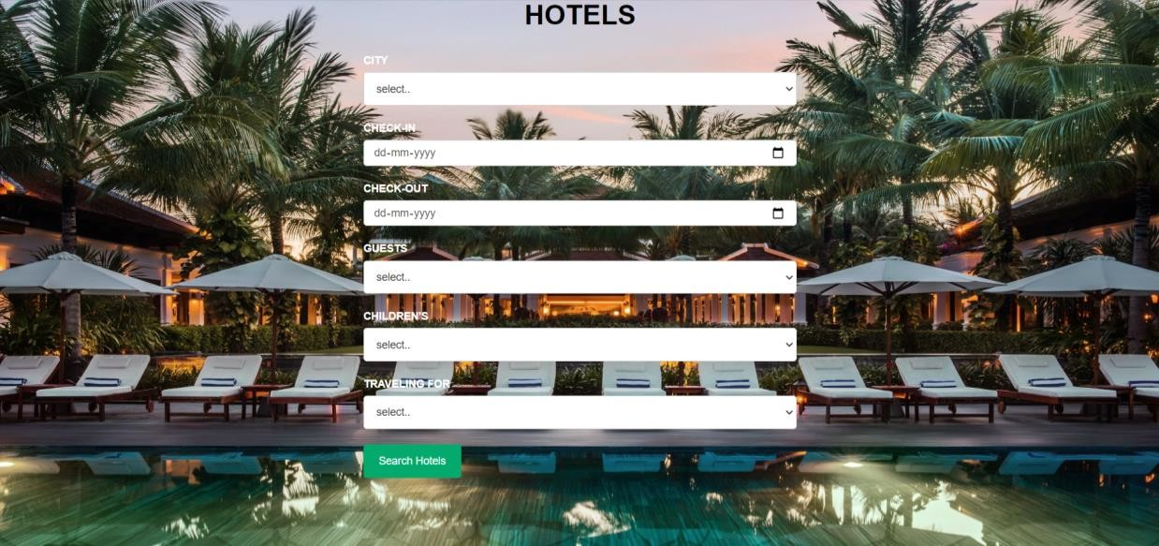

# Fig 8.1

# Homes

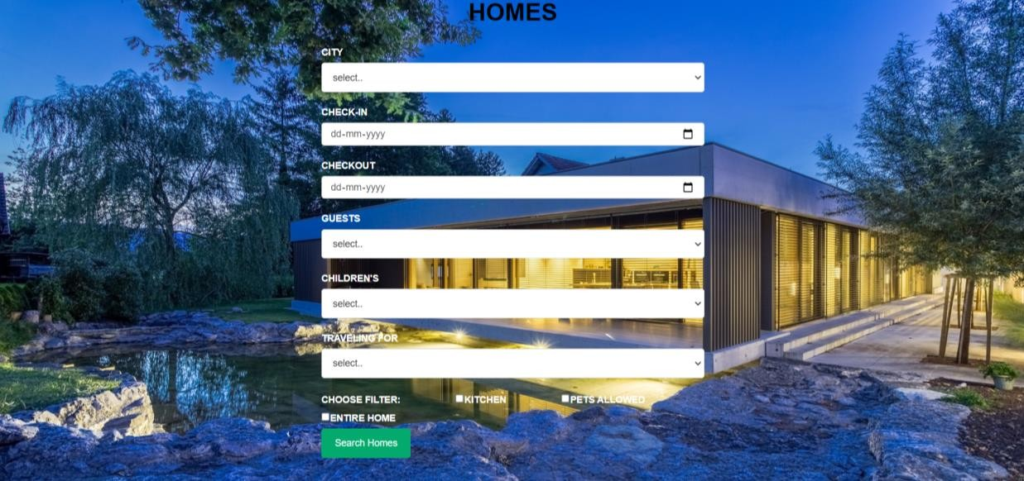

# Fig 9.1

1. **Contact Us**

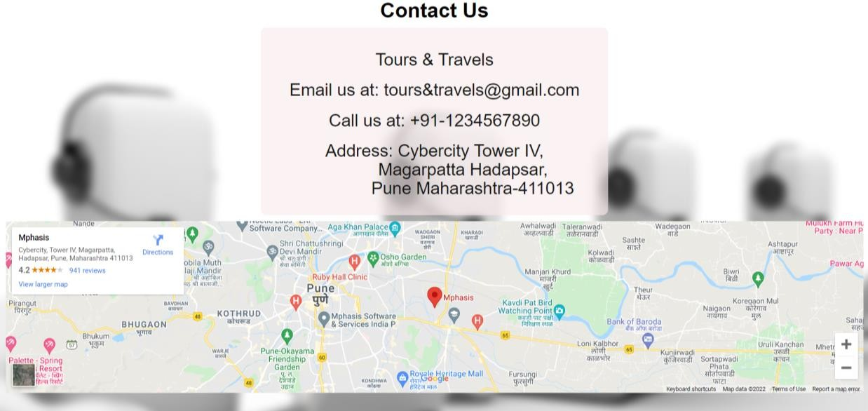

# Fig 10.1

1. Feedback

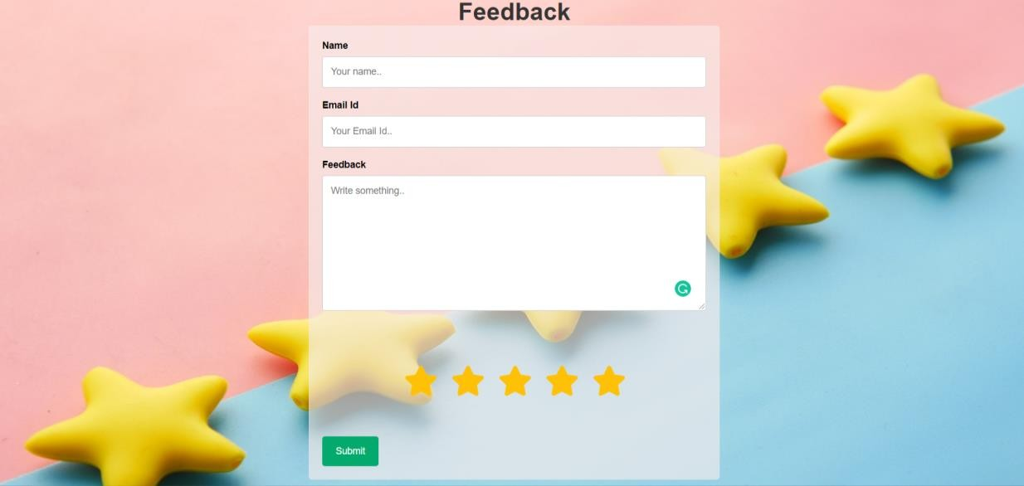

# Fig 11.1

1. **About Us**

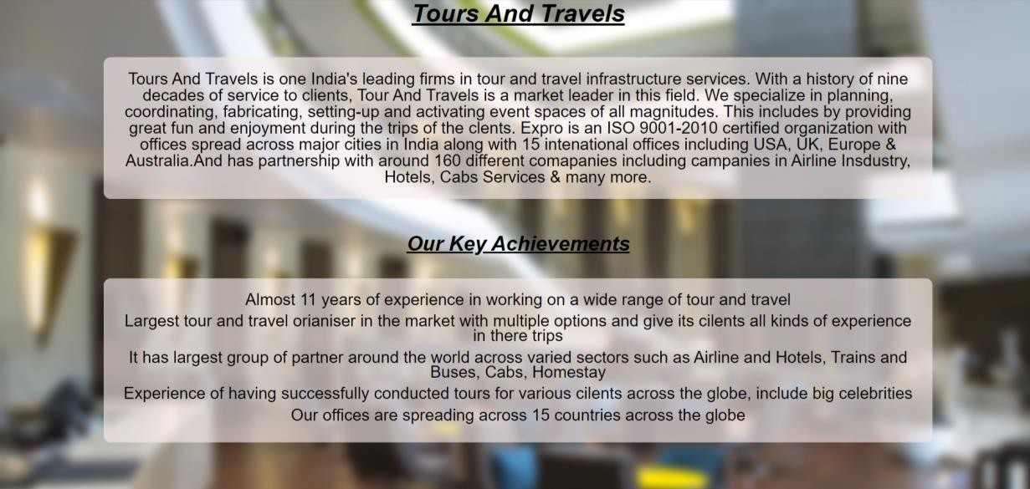

# Fig 12.1

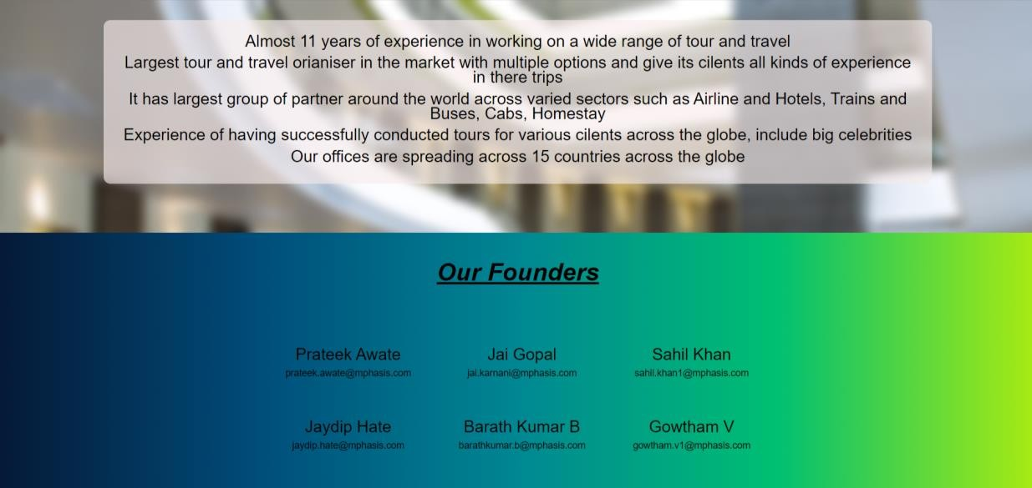

# Fig 12.2

# Source Code

# Home

# <!DOCTYPE html>

# <html lang=en>

# <body>

# <div id="demo" class="carousel slide" data-ride="carousel">

# <div class="carousel-inner">

# <div class="carousel-item active">

# <img src="/assets/home6.jpg" alt="Los Angeles" >

# <div class="centered" style="color: black;"><b>ONE STOP FOR "YOUR TRAVEL PLANS"</b></div>

# <div class="carousel-caption">

# <br> <br> <br>

# <h1 style="font-size:30px ;">India's Biggest "TOURS AND TRAVELS Management" Company</h1>

# <h1 style="font-size:30px ;"> Every tour should be enjoyable</h1>

# </div>

# </div>

# </div>

# </div>

# <h2>OUR TRIPS PHOTOS & OUR PARTNERS</h2>

# <div class="row">

# <b><h3>OUR SOUTH TRIP</h3></b>

# <div class="column">

# <img src="../../assets/south/img1.jpg" alter="no image" style="width:100%">

# </div>

# <div class="column">

# <img src="../../assets/south/img2.jpg" alter="no image" style="width:100%">

# </div>

# <div class="column">

# <img src="../../assets/south/img3.jpg" alter="no image" style="width:100%">

# </div>

# <div class="column">

# <img src="../../assets/south/img4.jpg" alter="no image" style="width:100%">

# </div>

# <div class="column">

# <img src="../../assets/south/img5.jpg" alter="no image" style="width:100%">

# </div>

# <div class="column">

# <img src="../../assets/south/img6.jpg" alter="no image" style="width:100%">

# </div>

# </div>

# <div class="row">

# <b><h3>OUR NORTH TRIP</h3></b>

# <div class="column">

# <img src="../../assets/north/img1.jpg" alter="no image" style="width:100%">

# </div>

# <div class="column">

# <img src="../../assets/north/img2.jpg" alter="no image" style="width:100%">

# </div>

# <div class="column">

# <img src="../../assets/north/img3.jpg" alter="no image" style="width:100%">

# </div>

# <div class="column">

# <img src="../../assets/north/img4.jpg" alter="no image" style="width:100%">

# </div>

# <div class="column">

# <img src="../../assets/north/img5.jpg" alter="no image" style="width:100%">

# </div>

# <div class="column">

# <img src="../../assets/north/img6.jpg" alter="no image" style="width:100%">

# </div>

# </div>

# <div class="row">

# <b><h3>OUR EAST TRIP</h3></b>

# <div class="column">

# <img src="../../assets/east/img1.jpg" alter="no image" style="width:100%">

# </div>

# <div class="column">

# <img src="../../assets/east/img2.jpg" alter="no image" style="width:100%">

# </div>

# <div class="column">

# <img src="../../assets/east/img3.jpg" alter="no image" style="width:100%">

# </div>

# <div class="column">

# <img src="../../assets/east/img4.jpg" alter="no image" style="width:100%">

# </div>

# <div class="column">

# <img src="../../assets/east/img5.jpg" alter="no image" style="width:100%">

# </div>

# <div class="column">

# <img src="../../assets/east/img6.jpg" alter="no image" style="width:100%">

# </div>

# </div>

# <div class="row">

# <b><h3>OUR PARTNERS</h3></b>

# <div class="column">

# <img src="../../assets/partners/img1.png" alter="no image" style="width:100%">

# </div>

# <div class="column">

# <img src="../../assets/partners/img2.png" alter="no image" style="width:100%">

# </div>

# <div class="column">

# <img src="../../assets/partners/img3.png" alter="no image" style="width:100%">

# </div>

# <div class="column">

# <img src="../../assets/partners/img4.jpg" alter="no image" style="width:100%">

# </div>

# <div class="column">

# <img src="../../assets/partners/img5.jpg" alter="no image" style="width:100%">

# </div>

# <div class="column">

# <img src="../../assets/partners/img6.png" alter="no image" style="width:100%">

# </div>

# </div>

# <div class="footer">

# <p style="font-size: larger" >ThankYou...Visit Again</p>

# <p> Opening time : Monday-Thursday:08:00-22:00</p>

# <p> Friday-Saturday:09:00-23:00</p>

# <p>Sunday:10:00-17:00</p>

# <p>Address: Cybercity, Tower IV,

# Magarpatta, Hadapsar,

# Pune, Maharashtra 411013</p>

# <a routerLink="#"><i class="fab fa-facebook"></i></a> &nbsp;

# <a routerLink="#"><i class="fab fa-twitter"></i></a> &nbsp;

# <a routerLink="#"><i class="fab fa-google"></i></a> &nbsp;

# <a routerLink="#"><i class="fab fa-linkedin"></i></a> &nbsp;

# <a routerLink="#"><i class="fab fa-instagram"></i></a> &nbsp;

# </div>

# </body>

# </html>

# .carousel-inner img {

# width: 100%;

# height: 600px;

# background-repeat: no-repeat;

# background-size: auto;

# overflow: hidden;

# }

# .centered {

# color: aliceblue;

# position: absolute;

# text-align:center;

# font-family:'Lucida Sans', 'Lucida Sans Regular', 'Lucida Grande', 'Lucida Sans Unicode', Geneva, Verdana, sans-serif ;

# font-size: 70px;

# top: 35%;

# left: 50%;

# opacity: 0.9;

# transform: translate(-50%, -50%);

# }

# body {margin:0;

# background-repeat: no-repeat;

# background-attachment: fixed;

# background-size: cover;

# }

# .container1 {

# border: 2px solid #ccc;

# background-color:lightgrey;

# border-radius: 5px;

# padding: 16px;

# margin: 16px 0

# }

# #about {

# padding: 100px 0px;

# position: relative;

# z-index: 9;

# }

# @media (max-width: 992px) {

# .features-item {

# margin-bottom: 45px;

# }

# }

# .features-item img {

# z-index: 10;

# position: relative;

# max-width: 100%;

# margin-bottom: 40px;

# }

# h3,h2,p{

# color: black;

# text-align: center;

# }

# h1{

# 

# color: black;

# }

# .features-item .main-button {

# margin-top: 35px;

# display: inline-block;

# }

# </*------------------------for images-----------------------*/>

# *{

# box-sizing:border-box;

# }

# 

# .column

# {

# float:left;

# width: 16.2%;

# padding:25px;

# }

# 

# .row

# {

# display:table;

# }

# .footer {

# 

# 

# padding: 40px;

# text-align: center;

# 

# font-size: medium;

# background-color: #000;

# color: white;

# }

# .fa {

# padding: 20px;

# font-size: 30px;

# width: 50px;

# text-align: center;

# text-decoration: none;

# margin: 5px 2px;

# }

# .fa:hover {

# opacity: 0.7;

# }

# .fa-facebook {

# color: white;

# }

# .fa-twitter {

# 

# color: white;

# }

# .fa-google {

# 

# color: white;

# }

# .fa-linkedin {

# 

# color: white;

# }

# .fa-instagram {

# 

# color: white;

# }

# p{

# color: white;

# }

# Log in

# <html>

# <body>

# <h1>Login</h1>

# <form action="action_page.php" method="post">

# <div class="imgcontainer">

# </div>

# <div class="container">

# <label for="uname"><b>Username</b></label>

# <input type="text" placeholder="Enter Username" name="uname" required><br>

# <label for="psw"><b>Password</b></label>

# <input type="password" placeholder="Enter Password" name="psw" required><br>

# <label>Varification Code</label><br>

# <div>

# <label>{{code}}</label> &nbsp; &nbsp; <input type="button" (click)="refreshClick()" class="btn" value="Click"><br><br>

# <input type=number placeholder="Enter Varification Code" name="num">

# </div><br>

# <button type="submit">Login</button>

# <label>

# <input type="checkbox" checked="checked" name="remember"> Remember me

# </label>

# </div>

# </form>

# </body>

# </html>

# body

# {

# height: 100%;

# background-image: url("../../assets/sign2.jpg");

# background-repeat: no-repeat;

# background-attachment: fixed;

# background-size: cover;

# scrollbar-width: none;

# }

# 

# /* Full-width inputs */

# input[type=text], input[type=password] {

# width: 100%;

# padding: 12px 20px;

# margin: 8px 0;

# display: inline-block;

# border: 1px solid lightslategrey;

# box-sizing: border-box;

# }

# 

# /* Set a style for all buttons */

# button {

# background-color: #04AA6D;

# color: white;

# padding: 14px 20px;

# margin: 8px 0;

# border: none;

# cursor: pointer;

# width: 100%;

# }

# 

# /* Add a hover effect for buttons */

# button:hover {

# opacity: 0.8;

# }

# 

# /* Extra style for the cancel button (red) */

# .cancelbtn {

# width: auto;

# padding: 10px 18px;

# background-color: #f44336;

# }

# 

# /* Center the avatar image inside this container */

# .imgcontainer {

# text-align: center;

# margin: 24px 0 12px 0;

# }

# 

# /* Avatar image */

# img.avatar {

# width: 40%;

# border-radius: 50%;

# }

# 

# /* Add padding to containers */

# .container {

# border-radius: 5px;

# padding: 10px;

# }

# 

# /* The "Forgot password" text */

# span.psw {

# float: right;

# padding-top: 16px;

# }

# 

# /* Change styles for span and cancel button on extra small screens */

# @media screen and (max-width: 300px) {

# span.psw {

# display: block;

# float: none;

# }

# .cancelbtn {

# width: 100%;

# }

# }

# h1{

# text-align: center;

# color: white;

# }

# label{

# color: white;

# }

# Sign up

# <!doctype html>

# <html lang="en">

# <head>

# <meta charset="utf-8">

# <title>Toursandtravels</title>

# <base href="/">

# <meta name="viewport" content="width=device-width, initial-scale=1">

# <link rel="icon" type="image/x-icon" href="favicon.ico">

# </head>

# <body>

# <app-root>Loading......</app-root>

# </body>

# </html>

# html, body {

# height: 100%;

# width: 100%;

# background-image: linear-gradient(to right, #051937, #004d7a, #008793, #00bf72, #a8eb12);

# }

# body

# {

# background-repeat: no-repeat;

# background-attachment: fixed;

# background-size: cover;

# }

# h1,h2,h3,h4,h5,h6{

# font-weight: 10px;

# color: black;

# 

# }

# label{

# color: black;

# }

# Flight

# <html>

# <body>

# <h1>FLIGHTS</h1>

# <div class="container">

# <form action="/action_page.php">

# <label for="oneway"><input type="radio" checked="checked" name="radio">ONEWAY TRIP<span class="checkmark"></span></label> &nbsp; &nbsp; &nbsp; &nbsp; &nbsp; &nbsp; &nbsp; &nbsp; &nbsp; &nbsp; <label for="round"><input type="radio" checked="checked" name="radio">ROUND TRIP<span class="checkmark"></span></label><br><br>

# <label for="from">FROM</label>

# <select name="from">

# <option>select..</option>

# <option>GOA</option>

# <option>Mumbai</option>

# <option>New Delhi</option>

# <option>Bengluru</option>

# <option>Jaipur</option>

# <option>GOHATI</option>

# <option>KOLATA</option>

# <option>SRINAGAR</option>

# <option>LUCKNOW</option>

# <option>CHENNAI</option>

# </select><br><br>

# <label for="to">TO</label>

# <select name="to">

# <option>select..</option>

# <option>GOA</option>

# <option>Mumbai</option>

# <option>New Delhi</option>

# <option>Bengluru</option>

# <option>Jaipur</option>

# <option>GOHATI</option>

# <option>KOLATA</option>

# <option>SRINAGAR</option>

# <option>LUCKNOW</option>

# <option>CHENNAI</option>

# </select><br><br>

# <label for="ddate">DEPARTURE</label>

# <input type="date" class="form-control" id="date" placeholder="Enter Departure Date" name=t1 required><br>

# <label for="rdate">RETURN</label>

# <input type="date" class="form-control" id="date" placeholder="Enter Return Date" name=t1><br>

# <label for="travelers">TRAVELERS</label>

# <select name="travelers">

# <option>select..</option>

# <option>1</option>

# <option>2</option>

# <option>3</option>

# <option>4</option>

# <option>5</option>

# <option>6</option>

# <option>7</option>

# <option>8</option>

# <option>9</option>

# <option>10</option>

# </select><br><br>

# <label for="children">CHILDREN'S</label>

# <select name="travelers">

# <option>select..</option>

# <option>1</option>

# <option>2</option>

# <option>3</option>

# <option>4</option>

# <option>5</option>

# </select><br><br>

# </form>

# <input type="button" value="Search Flight" text-align="center">

# </div>

# </body>

# </html>

# body {

# height: 100%;

# background-image: url(../../assets/flight.jpg);

# font-family: Arial, Helvetica, sans-serif;

# background-repeat: no-repeat;

# background-attachment: fixed;

# background-size: cover;

# }

# * {box-sizing: border-box;}

# input[type=text], select, textarea {

# width: 100%;

# padding: 12px;

# border: 1px solid #ccc;

# border-radius: 4px;

# box-sizing: border-box;

# resize: vertical;

# }

# input[type=button] {

# background-color: #04AA6D;

# color: white;

# padding: 12px 20px;

# border: none;

# border-radius: 4px;

# cursor: pointer;

# }

# .container {

# border-radius: 5px;

# padding: 10px;

# }

# button{

# text-align-last: center;

# }

# h1{

# color: white;

# text-align: center;

# }

# .fare{

# color: white;

# }

# 5.Train

# 

# <!DOCTYPE html>

# <html lang="en">

# <head>

# <link rel="stylesheet" href="https://use.fontawesome.com/releases/v5.7.0/css/all.css" integrity="sha384-lZN37f5QGtY3VHgisS14W3ExzMWZxybE1SJSEsQp9S+oqd12jhcu+A56Ebc1zFSJ" crossorigin="anonymous">

# <title>Bootstrap Example</title>

# <meta charset="utf-8">

# <meta name="viewport" content="width=device-width, initial-scale=1">

# <link rel="stylesheet" href="https://maxcdn.bootstrapcdn.com/bootstrap/3.4.1/css/bootstrap.min.css">

# <script src="https://ajax.googleapis.com/ajax/libs/jquery/3.5.1/jquery.min.js"></script>

# <script src="https://maxcdn.bootstrapcdn.com/bootstrap/3.4.1/js/bootstrap.min.js"></script>

# </head>

# <body>

# <nav class="navbar navbar-inverse">

# <div class="container-fluid">

# <div class="navbar-header">

# <a class="navbar-brand"><span class="glyphicon glyphicon-globe"></span> Tours And Travels</a>

# </div>

# <ul class="nav navbar-nav">

# <li class="active" routerLinkActive="active"><a routerLink="Home">Home</a></li>

# <li routerLinkActive="active"><a routerLink="Flight"><i class="fas fa-plane"></i> Flights</a></li>

# <li routerLinkActive="active"><a routerLink="Train"><i class="fas fa-train"></i> Trains</a></li>

# <li routerLinkActive="active"><a routerLink="Bus"><i class="fas fa-bus"></i> Buses</a></li>

# <li routerLinkActive="active"><a routerLink="Cab"><i class="fas fa-car"></i> Cabs</a></li>

# <li routerLinkActive="active"><a routerLink="Hotel"><i class="fas fa-hotel"></i> Hotels</a></li>

# <li routerLinkActive="active"><a routerLink="Homestay"><i class="fas fa-home"></i> HomeStay</a></li>

# <li routerLinkActive="active"><a routerLink="Contactus"><i class="fas fa-phone"></i> Contact Us</a></li>

# <li routerLinkActive="active"><a routerLink="Feedback"><i class="fas fa-comments"></i> Feedback</a></li>

# <li routerLinkActive="active"><a routerLink="Aboutus"><i class="fas fa-info-circle"></i> About Us</a></li>

# </ul>

# <ul class="nav navbar-nav navbar-right">

# <li routerLinkActive="active"><a routerLink="Registration"><span class="glyphicon glyphicon-user"></span> Sign Up</a></li>

# <li routerLinkActive="active"><a routerLink="Login"><span class="glyphicon glyphicon-log-in"></span> Login</a></li>

# </ul>

# </div>

# </nav>

# <router-outlet> </router-outlet>

# </body>

# </html>

# import { NgModule } from '@angular/core';

# import { BrowserModule } from '@angular/platform-browser';

# import { AppRoutingModule } from './app-routing.module';

# import { AppComponent } from './app.component';

# import { LoginComponent } from './login/login.component';

# import { CapchaService } from './login/login.service';

# import { RegistrationComponent } from './registration/registration.component';

# import { RouterModule,Routes } from '@angular/router';

# import { ContactusComponent } from './contactus/contactus.component';

# import { FeedbackComponent } from './feedback/feedback.component';

# import { AboutusComponent } from './aboutus/aboutus.component';

# import { HomeComponent } from './home/home.component';

# import { FlightComponent } from './flight/flight.component';

# import { TrainComponent } from './train/train.component';

# import { BusComponent } from './bus/bus.component';

# import { CabComponent } from './cab/cab.component';

# import { HotelComponent } from './hotel/hotel.component';

# import { HomestayComponent } from './homestay/homestay.component';

# const appRoutes: Routes=[

# {path:'Registration',component:RegistrationComponent},

# {path:'Login',component:LoginComponent},

# {path:'Contactus',component:ContactusComponent},

# {path:'Feedback',component:FeedbackComponent},

# {path:'Aboutus',component:AboutusComponent},

# {path:'Flight',component:FlightComponent},

# {path:'Train',component:TrainComponent},

# {path:'Bus',component:BusComponent},

# {path:'Cab',component:CabComponent},

# {path:'Hotel',component:HotelComponent},

# {path:'Homestay',component:HomestayComponent},

# {path:'Home',component:HomeComponent},

# ];

# @NgModule({

# declarations: [

# AppComponent,

# LoginComponent,

# RegistrationComponent,

# ContactusComponent,

# FeedbackComponent,

# AboutusComponent,

# HomeComponent,

# FlightComponent,

# TrainComponent,

# BusComponent,

# CabComponent,

# HotelComponent,

# HomestayComponent,

# ],

# imports: [

# BrowserModule,

# AppRoutingModule,

# RouterModule.forRoot(appRoutes),

# ],

# providers: [ CapchaService ],

# bootstrap: [ AppComponent ]

# })

# export class AppModule { }

# import { TestBed } from '@angular/core/testing';

# import { RouterTestingModule } from '@angular/router/testing';

# import { AppComponent } from './app.component';

# describe('AppComponent', () => {

# beforeEach(async () => {

# await TestBed.configureTestingModule({

# imports: [

# RouterTestingModule

# ],

# declarations: [

# AppComponent

# ],

# }).compileComponents();

# });

# it('should create the app', () => {

# const fixture = TestBed.createComponent(AppComponent);

# const app = fixture.componentInstance;

# expect(app).toBeTruthy();

# });

# it(`should have as title 'toursandtravels'`, () => {

# const fixture = TestBed.createComponent(AppComponent);

# const app = fixture.componentInstance;

# expect(app.title).toEqual('toursandtravels');

# });

# it('should render title', () => {

# const fixture = TestBed.createComponent(AppComponent);

# fixture.detectChanges();

# const compiled = fixture.nativeElement as HTMLElement;

# expect(compiled.querySelector('.content span')?.textContent).toContain('toursandtravels app is running!');

# });

# });

# import { NgModule } from '@angular/core';

# import { RouterModule, Routes } from '@angular/router';

# const routes: Routes = [];

# @NgModule({

# imports: [RouterModule.forRoot(routes)],

# exports: [RouterModule]

# })

# export class AppRoutingModule { }

# 6.Buses

# 

# <html>

# <body>

# <h1>BUSES</h1>

# <div class="container">

# <form action="/action_page.php">

# <label for="from">FROM</label>

# <select name="from">

# <option>select..</option>

# <option>GOA</option>

# <option>Mumbai</option>

# <option>New Delhi</option>

# <option>Bengluru</option>

# <option>Jaipur</option>

# <option>GOHATI</option>

# <option>KOLATA</option>

# <option>SRINAGAR</option>

# <option>LUCKNOW</option>

# <option>CHENNAI</option>

# </select><br><br>

# <label for="to">TO</label>

# <select name="to">

# <option>select..</option>

# <option>GOA</option>

# <option>Mumbai</option>

# <option>New Delhi</option>

# <option>Bengluru</option>

# <option>Jaipur</option>

# <option>GOHATI</option>

# <option>KOLATA</option>

# <option>SRINAGAR</option>

# <option>LUCKNOW</option>

# <option>CHENNAI</option>

# </select><br><br>

# <label for="tdate">TRAVEL DATE</label>

# <input type="date" class="form-control" id="tdate" placeholder="Enter Travel Date" name=t1 required><br>

# <label for="seats">NUMBER OF SEATS</label>

# <select name="seats">

# <option>select..</option>

# <option>1</option>

# <option>2</option>

# <option>3</option>

# <option>4</option>

# <option>5</option>

# <option>6</option>

# <option>7</option>

# <option>8</option>

# <option>9</option>

# <option>10</option>

# </select><br><br>

# <label for="seats">SEATS TYPE</label>

# <select name="seats">

# <option>select..</option>

# <option>SEATING</option>

# <option>SLEEPER</option>

# <option>SEMI SLEEPER</option>

# </select><br><br>

# </form>

# <input type="button" value="Search Buses" text-align="center">

# </div>

# </body>

# </html>

# <html>

# <body>

# <h1>BUSES</h1>

# <div class="container">

# <form action="/action_page.php">

# <label for="from">FROM</label>

# <select name="from">

# <option>select..</option>

# <option>GOA</option>

# <option>Mumbai</option>

# <option>New Delhi</option>

# <option>Bengluru</option>

# <option>Jaipur</option>

# <option>GOHATI</option>

# <option>KOLATA</option>

# <option>SRINAGAR</option>

# <option>LUCKNOW</option>

# <option>CHENNAI</option>

# </select><br><br>

# <label for="to">TO</label>

# <select name="to">

# <option>select..</option>

# <option>GOA</option>

# <option>Mumbai</option>

# <option>New Delhi</option>

# <option>Bengluru</option>

# <option>Jaipur</option>

# <option>GOHATI</option>

# <option>KOLATA</option>

# <option>SRINAGAR</option>

# <option>LUCKNOW</option>

# <option>CHENNAI</option>

# </select><br><br>

# <label for="tdate">TRAVEL DATE</label>

# <input type="date" class="form-control" id="tdate" placeholder="Enter Travel Date" name=t1 required><br>

# <label for="seats">NUMBER OF SEATS</label>

# <select name="seats">

# <option>select..</option>

# <option>1</option>

# <option>2</option>

# <option>3</option>

# <option>4</option>

# <option>5</option>

# <option>6</option>

# <option>7</option>

# <option>8</option>

# <option>9</option>

# <option>10</option>

# </select><br><br>

# <label for="seats">SEATS TYPE</label>

# <select name="seats">

# <option>select..</option>

# <option>SEATING</option>

# <option>SLEEPER</option>

# <option>SEMI SLEEPER</option>

# </select><br><br>

# </form>

# <input type="button" value="Search Buses" text-align="center">

# </div>

# </body>

# </html>

# body {

# height: 100%;

# background-image: url(../../assets/bus5.jpg);

# font-family: Arial, Helvetica, sans-serif;

# background-repeat: no-repeat;

# background-attachment: fixed;

# background-size: cover;

# }

# * {box-sizing: border-box;}

# input[type=text], select, textarea {

# width: 100%;

# padding: 12px;

# border: 1px solid #ccc;

# border-radius: 4px;

# box-sizing: border-box;

# resize: vertical;

# }

# input[type=button] {

# background-color: #04AA6D;

# color: white;

# padding: 12px 20px;

# border: none;

# border-radius: 4px;

# cursor: pointer;

# }

# .container {

# border-radius: 5px;

# padding: 10px;

# }

# h1{

# color: white;

# text-align: center;

# }

# label{

# color: white;

# } body {

# height: 100%;

# background-image: url(../../assets/bus5.jpg);

# font-family: Arial, Helvetica, sans-serif;

# background-repeat: no-repeat;

# background-attachment: fixed;

# background-size: cover;

# }

# * {box-sizing: border-box;}

# input[type=text], select, textarea {

# width: 100%;

# padding: 12px;

# border: 1px solid #ccc;

# border-radius: 4px;

# box-sizing: border-box;

# resize: vertical;

# }

# input[type=button] {

# background-color: #04AA6D;

# color: white;

# padding: 12px 20px;

# border: none;

# border-radius: 4px;

# cursor: pointer;

# }

# .container {

# border-radius: 5px;

# padding: 10px;

# }

# h1{

# color: white;

# text-align: center;

# }

# label{

# color: white;

# }

# 7. Cab

# <html>

# <body>

# <h1>CABS</h1>

# <div class="container">

# <form action="/action_page.php">

# <label for="oneway"><input type="radio" checked="checked" name="radio">OUTSTATION ONEWAY TRIP<span

# class="checkmark"></span></label> &nbsp; &nbsp; &nbsp; &nbsp; &nbsp; &nbsp; &nbsp; &nbsp; &nbsp;

# &nbsp; <label for="round"><input type="radio" checked="checked" name="radio">OUTSTATION ROUND TRIP<span

# class="checkmark"></span></label><br><br>

# <label for="from">FROM</label>

# <select name="from">

# <option>select..</option>

# <option>GOA</option>

# <option>Mumbai</option>

# <option>New Delhi</option>

# <option>Bengluru</option>

# <option>Jaipur</option>

# <option>GOHATI</option>

# <option>KOLATA</option>

# <option>SRINAGAR</option>

# <option>LUCKNOW</option>

# <option>CHENNAI</option>

# </select><br><br>

# <label for="to">TO</label>

# <select name="to">

# <option>select..</option>

# <option>GOA</option>

# <option>Mumbai</option>

# <option>New Delhi</option>

# <option>Bengluru</option>

# <option>Jaipur</option>

# <option>GOHATI</option>

# <option>KOLATA</option>

# <option>SRINAGAR</option>

# <option>LUCKNOW</option>

# <option>CHENNAI</option>

# </select><br><br>

# <label for="ddate">DEPARTURE</label>

# <input type="date" class="form-control" id="date" placeholder="Enter Departure Date" name=t1 required><br>

# <label for="rdate">RETURN</label>

# <input type="date" class="form-control" id="date" placeholder="Enter Return Date" name=t1><br>

# <label for="ptime">PICK UP TIME</label>

# <select name="ptime">

# <option>select..</option>

# <option>12 AM</option>

# <option>1 AM</option>

# <option>2 AM</option>

# <option>3 AM</option>

# <option>4 AM</option>

# <option>5 AM</option>

# <option>6 AM</option>

# <option>7 AM</option>

# <option>8 AM</option>

# <option>9 AM</option>

# <option>10 AM</option>

# <option>11 AM</option>

# <option>12 PM</option>

# <option>1 PM</option>

# <option>2 PM</option>

# <option>3 PM</option>

# <option>4 PM</option>

# <option>5 PM</option>

# <option>6 PM</option>

# <option>7 PM</option>

# <option>8 PM</option>

# <option>9 PM</option>

# <option>10 PM</option>

# <option>11 PM</option>

# </select><br><br>

# </form>

# <input type="button" value="Search Cabs" text-align="center">

# </div>

# </body>

# </html> <html>

# <body>

# <h1>CABS</h1>

# <div class="container">

# <form action="/action_page.php">

# <label for="oneway"><input type="radio" checked="checked" name="radio">OUTSTATION ONEWAY TRIP<span

# class="checkmark"></span></label> &nbsp; &nbsp; &nbsp; &nbsp; &nbsp; &nbsp; &nbsp; &nbsp; &nbsp;

# &nbsp; <label for="round"><input type="radio" checked="checked" name="radio">OUTSTATION ROUND TRIP<span

# class="checkmark"></span></label><br><br>

# <label for="from">FROM</label>

# <select name="from">

# <option>select..</option>

# <option>GOA</option>

# <option>Mumbai</option>

# <option>New Delhi</option>

# <option>Bengluru</option>

# <option>Jaipur</option>

# <option>GOHATI</option>

# <option>KOLATA</option>

# <option>SRINAGAR</option>

# <option>LUCKNOW</option>

# <option>CHENNAI</option>

# </select><br><br>

# <label for="to">TO</label>

# <select name="to">

# <option>select..</option>

# <option>GOA</option>

# <option>Mumbai</option>

# <option>New Delhi</option>

# <option>Bengluru</option>

# <option>Jaipur</option>

# <option>GOHATI</option>

# <option>KOLATA</option>

# <option>SRINAGAR</option>

# <option>LUCKNOW</option>

# <option>CHENNAI</option>

# </select><br><br>

# <label for="ddate">DEPARTURE</label>

# <input type="date" class="form-control" id="date" placeholder="Enter Departure Date" name=t1 required><br>

# <label for="rdate">RETURN</label>

# <input type="date" class="form-control" id="date" placeholder="Enter Return Date" name=t1><br>

# <label for="ptime">PICK UP TIME</label>

# <select name="ptime">

# <option>select..</option>

# <option>12 AM</option>

# <option>1 AM</option>

# <option>2 AM</option>

# <option>3 AM</option>

# <option>4 AM</option>

# <option>5 AM</option>

# <option>6 AM</option>

# <option>7 AM</option>

# <option>8 AM</option>

# <option>9 AM</option>

# <option>10 AM</option>

# <option>11 AM</option>

# <option>12 PM</option>

# <option>1 PM</option>

# <option>2 PM</option>

# <option>3 PM</option>

# <option>4 PM</option>

# <option>5 PM</option>

# <option>6 PM</option>

# <option>7 PM</option>

# <option>8 PM</option>

# <option>9 PM</option>

# <option>10 PM</option>

# <option>11 PM</option>

# </select><br><br>

# </form>

# <input type="button" value="Search Cabs" text-align="center">

# </div>

# </body>

# </html>

# body {

# height: 100%;

# background-image: url(../../assets/cab.jpg);

# font-family: Arial, Helvetica, sans-serif;

# background-repeat: no-repeat;

# background-attachment: fixed;

# background-size: cover;

# }

# * {box-sizing: border-box;}

# input[type=text], select, textarea {

# width: 100%;

# padding: 12px;

# border: 1px solid #ccc;

# border-radius: 4px;

# box-sizing: border-box;

# resize: vertical;

# }

# input[type=button] {

# background-color: #04AA6D;

# color: white;

# padding: 12px 20px;

# border: none;

# border-radius: 4px;

# cursor: pointer;

# }

# .container {

# border-radius: 5px;

# padding: 10px;

# }

# h1{

# color: white;

# text-align: center;

# }

# label{

# color: white;

# }

# 8. Hotel

# <html>

# <body>

# <h1>HOTELS</h1>

# <div class="container">

# <form action="/action_page.php">

# <label for="city">CITY</label>

# <select name="city">

# <option>select..</option>

# <option>GOA</option>

# <option>Mumbai</option>

# <option>New Delhi</option>

# <option>Bengluru</option>

# <option>Jaipur</option>

# <option>GOHATI</option>

# <option>KOLATA</option>

# <option>SRINAGAR</option>

# <option>LUCKNOW</option>

# <option>CHENNAI</option>

# </select><br><br>

# <label for="cidate">CHECK-IN</label>

# <input type="date" class="form-control" id="date" placeholder="Enter Departure Date" name=t1 required><br>

# <label for="codate">CHECK-OUT</label>

# <input type="date" class="form-control" id="date" placeholder="Enter Return Date" name=t1 required><br>

# <label for="travelers">GUESTS</label>

# <select name="travelers">

# <option>select..</option>

# <option>1</option>

# <option>2</option>

# <option>3</option>

# <option>4</option>

# <option>5</option>

# <option>6</option>

# <option>7</option>

# <option>8</option>

# <option>9</option>

# <option>10</option>

# </select><br><br>

# <label for="children">CHILDREN'S</label>

# <select name="travelers">

# <option>select..</option>

# <option>1</option>

# <option>2</option>

# <option>3</option>

# <option>4</option>

# <option>5</option>

# </select><br><br>

# <label for="reason">TRAVELING FOR</label>

# <select name="reason">

# <option>select..</option>

# <option>WORK</option>

# <option>HOLIDAY</option>

# </select><br><br>

# </form>

# <input type="button" value="Search Hotels" text-align="center">

# </div>

# </body>

# </html> <html>

# <body>

# <h1>HOTELS</h1>

# <div class="container">

# <form action="/action_page.php">

# <label for="city">CITY</label>

# <select name="city">

# <option>select..</option>

# <option>GOA</option>

# <option>Mumbai</option>

# <option>New Delhi</option>

# <option>Bengluru</option>

# <option>Jaipur</option>

# <option>GOHATI</option>

# <option>KOLATA</option>

# <option>SRINAGAR</option>

# <option>LUCKNOW</option>

# <option>CHENNAI</option>

# </select><br><br>

# <label for="cidate">CHECK-IN</label>

# <input type="date" class="form-control" id="date" placeholder="Enter Departure Date" name=t1 required><br>

# <label for="codate">CHECK-OUT</label>

# <input type="date" class="form-control" id="date" placeholder="Enter Return Date" name=t1 required><br>

# <label for="travelers">GUESTS</label>

# <select name="travelers">

# <option>select..</option>

# <option>1</option>

# <option>2</option>

# <option>3</option>

# <option>4</option>

# <option>5</option>

# <option>6</option>

# <option>7</option>

# <option>8</option>

# <option>9</option>

# <option>10</option>

# </select><br><br>

# <label for="children">CHILDREN'S</label>

# <select name="travelers">

# <option>select..</option>

# <option>1</option>

# <option>2</option>

# <option>3</option>

# <option>4</option>

# <option>5</option>

# </select><br><br>

# <label for="reason">TRAVELING FOR</label>

# <select name="reason">

# <option>select..</option>

# <option>WORK</option>

# <option>HOLIDAY</option>

# </select><br><br>

# </form>

# <input type="button" value="Search Hotels" text-align="center">

# </div>

# </body>

# </html>

# body {

# height: 100%;

# background-image: url(../../assets/hotel.jpg);

# font-family: Arial, Helvetica, sans-serif;

# background-repeat: no-repeat;

# background-attachment: fixed;

# background-size: cover;

# }

# * {box-sizing: border-box;}

# input[type=text], select, textarea {

# width: 100%;

# padding: 12px;

# border: 1px solid #ccc;

# border-radius: 4px;

# box-sizing: border-box;

# resize: vertical;

# }

# input[type=button] {

# background-color: #04AA6D;

# color: white;

# padding: 12px 20px;

# border: none;

# border-radius: 4px;

# cursor: pointer;

# }

# .container {

# border-radius: 5px;

# padding: 10px;

# }

# button{

# text-align-last: center;

# }

# h1{

# color: black;

# text-align: center;

# }

# label{

# color: white;

# } body {

# height: 100%;

# background-image: url(../../assets/hotel.jpg);

# font-family: Arial, Helvetica, sans-serif;

# background-repeat: no-repeat;

# background-attachment: fixed;

# background-size: cover;

# }

# * {box-sizing: border-box;}

# input[type=text], select, textarea {

# width: 100%;

# padding: 12px;

# border: 1px solid #ccc;

# border-radius: 4px;

# box-sizing: border-box;

# resize: vertical;

# }

# input[type=button] {

# background-color: #04AA6D;

# color: white;

# padding: 12px 20px;

# border: none;

# border-radius: 4px;

# cursor: pointer;

# }

# .container {

# border-radius: 5px;

# padding: 10px;

# }

# button{

# text-align-last: center;

# }

# h1{

# color: black;

# text-align: center;

# }

# label{

# color: white;

# }

# 9. Home

# 

# <!DOCTYPE html>

# <html lang=en>

# <body>

# <div id="demo" class="carousel slide" data-ride="carousel">

# <div class="carousel-inner">

# <div class="carousel-item active">

# <img src="/assets/home6.jpg" alt="Los Angeles" >

# <div class="centered" style="color: black;"><b>ONE STOP FOR "YOUR TRAVEL PLANS"</b></div>

# <div class="carousel-caption">

# <br> <br> <br>

# <h1 style="font-size:30px ;">India's Biggest "TOURS AND TRAVELS Management" Company</h1>

# <h1 style="font-size:30px ;"> Every tour should be enjoyable</h1>

# </div>

# </div>

# </div>

# </div>

# <h2>OUR TRIPS PHOTOS & OUR PARTNERS</h2>

# <div class="row">

# <b><h3>OUR SOUTH TRIP</h3></b>

# <div class="column">

# <img src="../../assets/south/img1.jpg" alter="no image" style="width:100%">

# </div>

# <div class="column">

# <img src="../../assets/south/img2.jpg" alter="no image" style="width:100%">

# </div>

# <div class="column">

# <img src="../../assets/south/img3.jpg" alter="no image" style="width:100%">

# </div>

# <div class="column">

# <img src="../../assets/south/img4.jpg" alter="no image" style="width:100%">

# </div>

# <div class="column">

# <img src="../../assets/south/img5.jpg" alter="no image" style="width:100%">

# </div>

# <div class="column">

# <img src="../../assets/south/img6.jpg" alter="no image" style="width:100%">

# </div>

# </div>

# <div class="row">

# <b><h3>OUR NORTH TRIP</h3></b>

# <div class="column">

# <img src="../../assets/north/img1.jpg" alter="no image" style="width:100%">

# </div>

# <div class="column">

# <img src="../../assets/north/img2.jpg" alter="no image" style="width:100%">

# </div>

# <div class="column">

# <img src="../../assets/north/img3.jpg" alter="no image" style="width:100%">

# </div>

# <div class="column">

# <img src="../../assets/north/img4.jpg" alter="no image" style="width:100%">

# </div>

# <div class="column">

# <img src="../../assets/north/img5.jpg" alter="no image" style="width:100%">

# </div>

# <div class="column">

# <img src="../../assets/north/img6.jpg" alter="no image" style="width:100%">

# </div>

# </div>

# <div class="row">

# <b><h3>OUR EAST TRIP</h3></b>

# <div class="column">

# <img src="../../assets/east/img1.jpg" alter="no image" style="width:100%">

# </div>

# <div class="column">

# <img src="../../assets/east/img2.jpg" alter="no image" style="width:100%">

# </div>

# <div class="column">

# <img src="../../assets/east/img3.jpg" alter="no image" style="width:100%">

# </div>

# <div class="column">

# <img src="../../assets/east/img4.jpg" alter="no image" style="width:100%">

# </div>

# <div class="column">

# <img src="../../assets/east/img5.jpg" alter="no image" style="width:100%">

# </div>

# <div class="column">

# <img src="../../assets/east/img6.jpg" alter="no image" style="width:100%">

# </div>

# </div>

# <div class="row">

# <b><h3>OUR PARTNERS</h3></b>

# <div class="column">

# <img src="../../assets/partners/img1.png" alter="no image" style="width:100%">

# </div>

# <div class="column">

# <img src="../../assets/partners/img2.png" alter="no image" style="width:100%">

# </div>

# <div class="column">

# <img src="../../assets/partners/img3.png" alter="no image" style="width:100%">

# </div>

# <div class="column">

# <img src="../../assets/partners/img4.jpg" alter="no image" style="width:100%">

# </div>

# <div class="column">

# <img src="../../assets/partners/img5.jpg" alter="no image" style="width:100%">

# </div>

# <div class="column">

# <img src="../../assets/partners/img6.png" alter="no image" style="width:100%">

# </div>

# </div>

# <div class="footer">

# <p style="font-size: larger" >ThankYou...Visit Again</p>

# <p> Opening time : Monday-Thursday:08:00-22:00</p>

# <p> Friday-Saturday:09:00-23:00</p>

# <p>Sunday:10:00-17:00</p>

# <p>Address: Cybercity, Tower IV,

# Magarpatta, Hadapsar,

# Pune, Maharashtra 411013</p>

# <a routerLink="#"><i class="fab fa-facebook"></i></a> &nbsp;

# <a routerLink="#"><i class="fab fa-twitter"></i></a> &nbsp;

# <a routerLink="#"><i class="fab fa-google"></i></a> &nbsp;

# <a routerLink="#"><i class="fab fa-linkedin"></i></a> &nbsp;

# <a routerLink="#"><i class="fab fa-instagram"></i></a> &nbsp;

# </div>

# </body>

# </html> <!DOCTYPE html>

# <html lang=en>

# <body>

# <div id="demo" class="carousel slide" data-ride="carousel">

# <div class="carousel-inner">

# <div class="carousel-item active">

# <img src="/assets/home6.jpg" alt="Los Angeles" >

# <div class="centered" style="color: black;"><b>ONE STOP FOR "YOUR TRAVEL PLANS"</b></div>

# <div class="carousel-caption">

# <br> <br> <br>

# <h1 style="font-size:30px ;">India's Biggest "TOURS AND TRAVELS Management" Company</h1>

# <h1 style="font-size:30px ;"> Every tour should be enjoyable</h1>

# </div>

# </div>

# </div>

# </div>

# <h2>OUR TRIPS PHOTOS & OUR PARTNERS</h2>

# <div class="row">

# <b><h3>OUR SOUTH TRIP</h3></b>

# <div class="column">

# <img src="../../assets/south/img1.jpg" alter="no image" style="width:100%">

# </div>

# <div class="column">

# <img src="../../assets/south/img2.jpg" alter="no image" style="width:100%">

# </div>

# <div class="column">

# <img src="../../assets/south/img3.jpg" alter="no image" style="width:100%">

# </div>

# <div class="column">

# <img src="../../assets/south/img4.jpg" alter="no image" style="width:100%">

# </div>

# <div class="column">

# <img src="../../assets/south/img5.jpg" alter="no image" style="width:100%">

# </div>

# <div class="column">

# <img src="../../assets/south/img6.jpg" alter="no image" style="width:100%">

# </div>

# </div>

# <div class="row">

# <b><h3>OUR NORTH TRIP</h3></b>

# <div class="column">

# <img src="../../assets/north/img1.jpg" alter="no image" style="width:100%">

# </div>

# <div class="column">

# <img src="../../assets/north/img2.jpg" alter="no image" style="width:100%">

# </div>

# <div class="column">

# <img src="../../assets/north/img3.jpg" alter="no image" style="width:100%">

# </div>

# <div class="column">

# <img src="../../assets/north/img4.jpg" alter="no image" style="width:100%">

# </div>

# <div class="column">

# <img src="../../assets/north/img5.jpg" alter="no image" style="width:100%">

# </div>

# <div class="column">

# <img src="../../assets/north/img6.jpg" alter="no image" style="width:100%">

# </div>

# </div>

# <div class="row">

# <b><h3>OUR EAST TRIP</h3></b>

# <div class="column">

# <img src="../../assets/east/img1.jpg" alter="no image" style="width:100%">

# </div>

# <div class="column">

# <img src="../../assets/east/img2.jpg" alter="no image" style="width:100%">

# </div>

# <div class="column">

# <img src="../../assets/east/img3.jpg" alter="no image" style="width:100%">

# </div>

# <div class="column">

# <img src="../../assets/east/img4.jpg" alter="no image" style="width:100%">

# </div>

# <div class="column">

# <img src="../../assets/east/img5.jpg" alter="no image" style="width:100%">

# </div>

# <div class="column">

# <img src="../../assets/east/img6.jpg" alter="no image" style="width:100%">

# </div>

# </div>

# <div class="row">

# <b><h3>OUR PARTNERS</h3></b>

# <div class="column">

# <img src="../../assets/partners/img1.png" alter="no image" style="width:100%">

# </div>

# <div class="column">

# <img src="../../assets/partners/img2.png" alter="no image" style="width:100%">

# </div>

# <div class="column">

# <img src="../../assets/partners/img3.png" alter="no image" style="width:100%">

# </div>

# <div class="column">

# <img src="../../assets/partners/img4.jpg" alter="no image" style="width:100%">

# </div>

# <div class="column">

# <img src="../../assets/partners/img5.jpg" alter="no image" style="width:100%">

# </div>

# <div class="column">

# <img src="../../assets/partners/img6.png" alter="no image" style="width:100%">

# </div>

# </div>

# <div class="footer">

# <p style="font-size: larger" >ThankYou...Visit Again</p>

# <p> Opening time : Monday-Thursday:08:00-22:00</p>

# <p> Friday-Saturday:09:00-23:00</p>

# <p>Sunday:10:00-17:00</p>

# <p>Address: Cybercity, Tower IV,

# Magarpatta, Hadapsar,

# Pune, Maharashtra 411013</p>

# <a routerLink="#"><i class="fab fa-facebook"></i></a> &nbsp;

# <a routerLink="#"><i class="fab fa-twitter"></i></a> &nbsp;

# <a routerLink="#"><i class="fab fa-google"></i></a> &nbsp;

# <a routerLink="#"><i class="fab fa-linkedin"></i></a> &nbsp;

# <a routerLink="#"><i class="fab fa-instagram"></i></a> &nbsp;

# </div>

# </body>

# </html>

# 10. Packages

# {

# "name": "tour",

# "version": "0.0.0",

# "lockfileVersion": 2,

# "requires": true,

# "packages": {

# "": {

# "name": "tour",

# "version": "0.0.0",

# "dependencies": {

# "@angular/animations": "~13.3.0",

# "@angular/common": "~13.3.0",

# "@angular/compiler": "~13.3.0",

# "@angular/core": "~13.3.0",

# "@angular/forms": "~13.3.0",

# "@angular/platform-browser": "~13.3.0",

# "@angular/platform-browser-dynamic": "~13.3.0",

# "@angular/router": "~13.3.0",

# "rxjs": "~7.5.0",

# "tslib": "^2.3.0",

# "zone.js": "~0.11.4"

# },

# "devDependencies": {

# "@angular-devkit/build-angular": "~13.3.6",

# "@angular/cli": "~13.3.6",

# "@angular/compiler-cli": "~13.3.0",

# "@types/jasmine": "~3.10.0",

# "@types/node": "^12.11.1",

# "jasmine-core": "~4.0.0",

# "karma": "~6.3.0",

# "karma-chrome-launcher": "~3.1.0",

# "karma-coverage": "~2.1.0",

# "karma-jasmine": "~4.0.0",

# "karma-jasmine-html-reporter": "~1.7.0",

# "typescript": "~4.6.2"

# }

# },

# "node_modules/@ampproject/remapping": {

# "version": "2.2.0",

# "resolved": "https://registry.npmjs.org/@ampproject/remapping/-/remapping-2.2.0.tgz",

# "integrity": "sha512-qRmjj8nj9qmLTQXXmaR1cck3UXSRMPrbsLJAasZpF+t3riI71BXed5ebIOYwQntykeZuhjsdweEc9BxH5Jc26w==",

# "dev": true,

# "dependencies": {

# "@jridgewell/gen-mapping": "^0.1.0",

# "@jridgewell/trace-mapping": "^0.3.9"

# },

# "engines": {

# "node": ">=6.0.0"

# }

# },

# "node_modules/@angular-devkit/architect": {

# "version": "0.1303.6",

# "resolved": "https://registry.npmjs.org/@angular-devkit/architect/-/architect-0.1303.6.tgz",

# "integrity": "sha512-Quh8KzO17PZH38mrDlBihrT6TioTnD8I+nSXuTZIqHwDpyFCTB9wBm9wC1J6HzMzEJ1GoYWEH/ukfbVpmj8ghw==",

# "dev": true,

# "dependencies": {

# "@angular-devkit/core": "13.3.6",

# "rxjs": "6.6.7"

# },

# "engines": {

# "node": "^12.20.0 || ^14.15.0 || >=16.10.0",

# "npm": "^6.11.0 || ^7.5.6 || >=8.0.0",

# "yarn": ">= 1.13.0"

# }

# },

# "node_modules/@angular-devkit/architect/node_modules/rxjs": {

# "version": "6.6.7",

# "resolved": "https://registry.npmjs.org/rxjs/-/rxjs-6.6.7.tgz",

# "integrity": "sha512-hTdwr+7yYNIT5n4AMYp85KA6yw2Va0FLa3Rguvbpa4W3I5xynaBZo41cM3XM+4Q6fRMj3sBYIR1VAmZMXYJvRQ==",

# "dev": true,

# "dependencies": {

# "tslib": "^1.9.0"

# },

# "engines": {

# "npm": ">=2.0.0"

# }

# },

# "node_modules/@angular-devkit/architect/node_modules/tslib": {

# "version": "1.14.1",

# "resolved": "https://registry.npmjs.org/tslib/-/tslib-1.14.1.tgz",

# "integrity": "sha512-Xni35NKzjgMrwevysHTCArtLDpPvye8zV/0E4EyYn43P7/7qvQwPh9BGkHewbMulVntbigmcT7rdX3BNo9wRJg==",

# "dev": true

# },

# "node_modules/@angular-devkit/build-angular": {

# "version": "13.3.6",

# "resolved": "https://registry.npmjs.org/@angular-devkit/build-angular/-/build-angular-13.3.6.tgz",

# "integrity": "sha512-VrEw9AhS0BBPRA59aZZYDXelXX8SdTfo7mW1gSeuvyeqk8RpMdjHWJPUmuvNJro6s5zOe4lc9dVrGxdevCbQFQ==",

# "dev": true,

# "dependencies": {

# "@ampproject/remapping": "2.2.0",

# "@angular-devkit/architect": "0.1303.6",

# "@angular-devkit/build-webpack": "0.1303.6",

# "@angular-devkit/core": "13.3.6",

# "@babel/core": "7.16.12",

# "@babel/generator": "7.16.8",

# "@babel/helper-annotate-as-pure": "7.16.7",

# "@babel/plugin-proposal-async-generator-functions": "7.16.8",

# "@babel/plugin-transform-async-to-generator": "7.16.8",

# "@babel/plugin-transform-runtime": "7.16.10",

# "@babel/preset-env": "7.16.11",

# "@babel/runtime": "7.16.7",

# "@babel/template": "7.16.7",

# "@discoveryjs/json-ext": "0.5.6",

# "@ngtools/webpack": "13.3.6",

# "ansi-colors": "4.1.1",

# "babel-loader": "8.2.5",

# "babel-plugin-istanbul": "6.1.1",

# "browserslist": "^4.9.1",

# "cacache": "15.3.0",

# "circular-dependency-plugin": "5.2.2",

# "copy-webpack-plugin": "10.2.1",

# "core-js": "3.20.3",

# "critters": "0.0.16",

# "css-loader": "6.5.1",

# "esbuild-wasm": "0.14.22",

# "glob": "7.2.0",

# "https-proxy-agent": "5.0.0",

# "inquirer": "8.2.0",

# "jsonc-parser": "3.0.0",

# "karma-source-map-support": "1.4.0",

# "less": "4.1.2",

# "less-loader": "10.2.0",

# "license-webpack-plugin": "4.0.2",

# "loader-utils": "3.2.0",

# "mini-css-extract-plugin": "2.5.3",

# "minimatch": "3.0.5",

# "open": "8.4.0",

# "ora": "5.4.1",

# "parse5-html-rewriting-stream": "6.0.1",

# "piscina": "3.2.0",

# "postcss": "8.4.5",

# "postcss-import": "14.0.2",

# "postcss-loader": "6.2.1",

# "postcss-preset-env": "7.2.3",

# "regenerator-runtime": "0.13.9",

# "resolve-url-loader": "5.0.0",

# "rxjs": "6.6.7",

# "sass": "1.49.9",

# "sass-loader": "12.4.0",

# "semver": "7.3.5",

# "source-map-loader": "3.0.1",

# "source-map-support": "0.5.21",

# "stylus": "0.56.0",

# "stylus-loader": "6.2.0",

# "terser": "5.11.0",

# "text-table": "0.2.0",

# "tree-kill": "1.2.2",

# "tslib": "2.3.1",

# "webpack": "5.70.0",

# "webpack-dev-middleware": "5.3.0",

# "webpack-dev-server": "4.7.3",

# "webpack-merge": "5.8.0",

# "webpack-subresource-integrity": "5.1.0"

# },

# "engines": {

# "node": "^12.20.0 || ^14.15.0 || >=16.10.0",

# "npm": "^6.11.0 || ^7.5.6 || >=8.0.0",

# "yarn": ">= 1.13.0"

# },

# "optionalDependencies": {

# "esbuild": "0.14.22"

# },

# "peerDependencies": {

# "@angular/compiler-cli": "^13.0.0 || ^13.3.0-rc.0",

# "@angular/localize": "^13.0.0 || ^13.3.0-rc.0",

# "@angular/service-worker": "^13.0.0 || ^13.3.0-rc.0",

# "karma": "^6.3.0",

# "ng-packagr": "^13.0.0",

# "protractor": "^7.0.0",

# "tailwindcss": "^2.0.0 || ^3.0.0",

# "typescript": ">=4.4.3 <4.7"

# },

# "peerDependenciesMeta": {

# "@angular/localize": {

# "optional": true

# },

# "@angular/service-worker": {

# "optional": true

# },

# "karma": {

# "optional": true

# },

# "ng-packagr": {

# "optional": true

# },

# "protractor": {

# "optional": true

# },

# "tailwindcss": {

# "optional": true

# }

# }

# },

# "node_modules/@angular-devkit/build-angular/node_modules/rxjs": {

# "version": "6.6.7",

# "resolved": "https://registry.npmjs.org/rxjs/-/rxjs-6.6.7.tgz",

# "integrity": "sha512-hTdwr+7yYNIT5n4AMYp85KA6yw2Va0FLa3Rguvbpa4W3I5xynaBZo41cM3XM+4Q6fRMj3sBYIR1VAmZMXYJvRQ==",

# "dev": true,

# "dependencies": {

# "tslib": "^1.9.0"

# },

# "engines": {

# "npm": ">=2.0.0"

# }

# },

# "node_modules/@angular-devkit/build-angular/node_modules/rxjs/node_modules/tslib": {

# "version": "1.14.1",

# "resolved": "https://registry.npmjs.org/tslib/-/tslib-1.14.1.tgz",

# "integrity": "sha512-Xni35NKzjgMrwevysHTCArtLDpPvye8zV/0E4EyYn43P7/7qvQwPh9BGkHewbMulVntbigmcT7rdX3BNo9wRJg==",

# "dev": true

# },

# "node_modules/@angular-devkit/build-angular/node_modules/tslib": {

# "version": "2.3.1",

# "resolved": "https://registry.npmjs.org/tslib/-/tslib-2.3.1.tgz",

# "integrity": "sha512-77EbyPPpMz+FRFRuAFlWMtmgUWGe9UOG2Z25NqCwiIjRhOf5iKGuzSe5P2w1laq+FkRy4p+PCuVkJSGkzTEKVw==",

# "dev": true

# },

# "node_modules/@angular-devkit/build-webpack": {

# "version": "0.1303.6",

# "resolved": "https://registry.npmjs.org/@angular-devkit/build-webpack/-/build-webpack-0.1303.6.tgz",

# "integrity": "sha512-T2Uwt57RGPNH5OOblWcWd4Q4NaOK0f2jNTH29L6kSFVlYQ7kKCe9xo3YdzVdiY5b4w/hfnDlpGR+J3aSkkmBRw==",

# "dev": true,

# "dependencies": {

# "@angular-devkit/architect": "0.1303.6",

# "rxjs": "6.6.7"

# },

# "engines": {

# "node": "^12.20.0 || ^14.15.0 || >=16.10.0",

# "npm": "^6.11.0 || ^7.5.6 || >=8.0.0",

# "yarn": ">= 1.13.0"

# },

# "peerDependencies": {

# "webpack": "^5.30.0",

# "webpack-dev-server": "^4.0.0"

# }

# },

# "node_modules/@angular-devkit/build-webpack/node_modules/rxjs": {

# "version": "6.6.7",

# "resolved": "https://registry.npmjs.org/rxjs/-/rxjs-6.6.7.tgz",

# "integrity": "sha512-hTdwr+7yYNIT5n4AMYp85KA6yw2Va0FLa3Rguvbpa4W3I5xynaBZo41cM3XM+4Q6fRMj3sBYIR1VAmZMXYJvRQ==",

# "dev": true,

# "dependencies": {

# "tslib": "^1.9.0"

# },

# "engines": {

# "npm": ">=2.0.0"

# }

# },

# "node_modules/@angular-devkit/build-webpack/node_modules/tslib": {

# "version": "1.14.1",

# "resolved": "https://registry.npmjs.org/tslib/-/tslib-1.14.1.tgz",

# "integrity": "sha512-Xni35NKzjgMrwevysHTCArtLDpPvye8zV/0E4EyYn43P7/7qvQwPh9BGkHewbMulVntbigmcT7rdX3BNo9wRJg==",

# "dev": true

# },

# "node_modules/@angular-devkit/core": {

# "version": "13.3.6",

# "resolved": "https://registry.npmjs.org/@angular-devkit/core/-/core-13.3.6.tgz",

# "integrity": "sha512-ZmD586B+RnM2CG5+jbXh2NVfIydTc/yKSjppYDDOv4I530YBm6vpfZMwClpiNk6XLbMv7KqX4Tlr4wfxlPYYbA==",

# "dev": true,

# "dependencies": {

# "ajv": "8.9.0",

# "ajv-formats": "2.1.1",

# "fast-json-stable-stringify": "2.1.0",

# "magic-string": "0.25.7",

# "rxjs": "6.6.7",

# "source-map": "0.7.3"

# },

# "engines": {

# "node": "^12.20.0 || ^14.15.0 || >=16.10.0",

# "npm": "^6.11.0 || ^7.5.6 || >=8.0.0",

# "yarn": ">= 1.13.0"

# },

# "peerDependencies": {

# "chokidar": "^3.5.2"

# },

# "peerDependenciesMeta": {

# "chokidar": {

# "optional": true

# }

# }

# },

# "node_modules/@angular-devkit/core/node_modules/rxjs": {

# "version": "6.6.7",

# "resolved": "https://registry.npmjs.org/rxjs/-/rxjs-6.6.7.tgz",

# "integrity": "sha512-hTdwr+7yYNIT5n4AMYp85KA6yw2Va0FLa3Rguvbpa4W3I5xynaBZo41cM3XM+4Q6fRMj3sBYIR1VAmZMXYJvRQ==",

# "dev": true,

# "dependencies": {

# "tslib": "^1.9.0"

# },

# "engines": {

# "npm": ">=2.0.0"

# }

# },

# "node_modules/@angular-devkit/core/node_modules/tslib": {

# "version": "1.14.1",

# "resolved": "https://registry.npmjs.org/tslib/-/tslib-1.14.1.tgz",

# "integrity": "sha512-Xni35NKzjgMrwevysHTCArtLDpPvye8zV/0E4EyYn43P7/7qvQwPh9BGkHewbMulVntbigmcT7rdX3BNo9wRJg==",

# "dev": true

# },

# "node_modules/@angular-devkit/schematics": {

# "version": "13.3.6",

# "resolved": "https://registry.npmjs.org/@angular-devkit/schematics/-/schematics-13.3.6.tgz",

# "integrity": "sha512-yLh5xc92C/FiaAp27coPiKWpSUmwoXF7vMxbJYJTyOXlt0mUITAEAwtrZQNr4yAxW/yvgTdyg7PhXaveQNTUuQ==",

# "dev": true,

# "dependencies": {

# "@angular-devkit/core": "13.3.6",

# "jsonc-parser": "3.0.0",

# "magic-string": "0.25.7",

# "ora": "5.4.1",

# "rxjs": "6.6.7"

# },

# "engines": {

# "node": "^12.20.0 || ^14.15.0 || >=16.10.0",

# "npm": "^6.11.0 || ^7.5.6 || >=8.0.0",

# "yarn": ">= 1.13.0"

# }

# },

# "node_modules/@angular-devkit/schematics/node_modules/rxjs": {

# "version": "6.6.7",

# "resolved": "https://registry.npmjs.org/rxjs/-/rxjs-6.6.7.tgz",

# "integrity": "sha512-hTdwr+7yYNIT5n4AMYp85KA6yw2Va0FLa3Rguvbpa4W3I5xynaBZo41cM3XM+4Q6fRMj3sBYIR1VAmZMXYJvRQ==",

# "dev": true,

# "dependencies": {

# "tslib": "^1.9.0"

# },

# "engines": {

# "npm": ">=2.0.0"

# }

# },

# "node_modules/@angular-devkit/schematics/node_modules/tslib": {

# "version": "1.14.1",

# "resolved": "https://registry.npmjs.org/tslib/-/tslib-1.14.1.tgz",

# "integrity": "sha512-Xni35NKzjgMrwevysHTCArtLDpPvye8zV/0E4EyYn43P7/7qvQwPh9BGkHewbMulVntbigmcT7rdX3BNo9wRJg==",

# "dev": true

# },

# "node_modules/@angular/animations": {

# "version": "13.3.9",

# "resolved": "https://registry.npmjs.org/@angular/animations/-/animations-13.3.9.tgz",

# "integrity": "sha512-PIspkNm1r7Uq1F3/c24mTQjCbKvl84Iy5kRmKOtjxp9uBGg1Dy+akw29hJt2FAqKa5yKFustBFCgWKypqgSoUQ==",

# "dependencies": {

# "tslib": "^2.3.0"

# },

# "engines": {

# "node": "^12.20.0 || ^14.15.0 || >=16.10.0"

# },

# "peerDependencies": {

# "@angular/core": "13.3.9"

# }

# },

# "node_modules/@angular/cli": {

# "version": "13.3.6",

# "resolved": "https://registry.npmjs.org/@angular/cli/-/cli-13.3.6.tgz",

# "integrity": "sha512-+OC7uspa8oDGQzcpml3DI8XyLvYurhSFhcmLPsyY/naHAV78NKSNf3dIWMPNozAioDzkZXPZXH0dwSdb+cOeQA==",

# "dev": true,

# "hasInstallScript": true,

# "dependencies": {

# "@angular-devkit/architect": "0.1303.6",

# "@angular-devkit/core": "13.3.6",

# "@angular-devkit/schematics": "13.3.6",

# "@schematics/angular": "13.3.6",

# "@yarnpkg/lockfile": "1.1.0",

# "ansi-colors": "4.1.1",

# "debug": "4.3.3",

# "ini": "2.0.0",

# "inquirer": "8.2.0",

# "jsonc-parser": "3.0.0",

# "npm-package-arg": "8.1.5",

# "npm-pick-manifest": "6.1.1",

# "open": "8.4.0",

# "ora": "5.4.1",

# "pacote": "12.0.3",

# "resolve": "1.22.0",

# "semver": "7.3.5",

# "symbol-observable": "4.0.0",

# "uuid": "8.3.2"

# },

# "bin": {

# "ng": "bin/ng.js"

# },

# "engines": {

# "node": "^12.20.0 || ^14.15.0 || >=16.10.0",

# "npm": "^6.11.0 || ^7.5.6 || >=8.0.0",

# "yarn": ">= 1.13.0"

# }

# },

# "node_modules/@angular/common": {

# "version": "13.3.9",

# "resolved": "https://registry.npmjs.org/@angular/common/-/common-13.3.9.tgz",

# "integrity": "sha512-+bTleNL1XGlzuxLbVbsol82/33IW2pJasQN8ViraxKIElT2F8ooBJevIBMCSIcdvxvMBGAjn4ayQJr6tkPqPaw==",

# "dependencies": {

# "tslib": "^2.3.0"

# },

# "engines": {

# "node": "^12.20.0 || ^14.15.0 || >=16.10.0"

# },

# "peerDependencies": {

# "@angular/core": "13.3.9",

# "rxjs": "^6.5.3 || ^7.4.0"

# }

# },

# "node_modules/@angular/compiler": {

# "version": "13.3.9",

# "resolved": "https://registry.npmjs.org/@angular/compiler/-/compiler-13.3.9.tgz",

# "integrity": "sha512-fXmcN9PIUTJ9Vw2QyQE9vtW95K5ML9bVI7409Zf3DAQJEo4IhX2eUjgiGF3RtSn9Kdjj3tZY0xSbGGwp1hTBIA==",

# "dependencies": {

# "tslib": "^2.3.0"

# },

# "engines": {

# "node": "^12.20.0 || ^14.15.0 || >=16.10.0"

# }

# },

# "node_modules/@angular/compiler-cli": {

# "version": "13.3.9",

# "resolved": "https://registry.npmjs.org/@angular/compiler-cli/-/compiler-cli-13.3.9.tgz",

# "integrity": "sha512-jf4iG7uqE1ZW2mJgKJyDyFby/sVQDlGOtUl68TMf8r06koWeny5nk/LhL7jp3Q6rgN2ZdYALtPTRSj7HVQD8pA==",

# "dev": true,

# "dependencies": {

# "@babel/core": "^7.17.2",

# "chokidar": "^3.0.0",

# "convert-source-map": "^1.5.1",

# "dependency-graph": "^0.11.0",

# "magic-string": "^0.26.0",

# "reflect-metadata": "^0.1.2",

# "semver": "^7.0.0",

# "sourcemap-codec": "^1.4.8",

# "tslib": "^2.3.0",

# "yargs": "^17.2.1"

# },

# "bin": {

# "ng-xi18n": "bundles/src/bin/ng_xi18n.js",

# "ngc": "bundles/src/bin/ngc.js",

# "ngcc": "bundles/ngcc/main-ngcc.js"

# },

# "engines": {

# "node": "^12.20.0 || ^14.15.0 || >=16.10.0"

# },

# "peerDependencies": {

# "@angular/compiler": "13.3.9",

# "typescript": ">=4.4.2 <4.7"

# }

# },

# "node_modules/@angular/compiler-cli/node_modules/@babel/core": {

# "version": "7.18.0",

# "resolved": "https://registry.npmjs.org/@babel/core/-/core-7.18.0.tgz",

# "integrity": "sha512-Xyw74OlJwDijToNi0+6BBI5mLLR5+5R3bcSH80LXzjzEGEUlvNzujEE71BaD/ApEZHAvFI/Mlmp4M5lIkdeeWw==",

# "dev": true,

# "dependencies": {

# "@ampproject/remapping": "^2.1.0",

# "@babel/code-frame": "^7.16.7",

# "@babel/generator": "^7.18.0",

# "@babel/helper-compilation-targets": "^7.17.10",

# "@babel/helper-module-transforms": "^7.18.0",

# "@babel/helpers": "^7.18.0",

# "@babel/parser": "^7.18.0",

# "@babel/template": "^7.16.7",

# "@babel/traverse": "^7.18.0",

# "@babel/types": "^7.18.0",

# "convert-source-map": "^1.7.0",

# "debug": "^4.1.0",

# "gensync": "^1.0.0-beta.2",

# "json5": "^2.2.1",

# "semver": "^6.3.0"

# },

# "engines": {

# "node": ">=6.9.0"

# },

# "funding": {

# "type": "opencollective",

# "url": "https://opencollective.com/babel"

# }

# },

# "node_modules/@angular/compiler-cli/node_modules/@babel/core/node_modules/semver": {

# "version": "6.3.0",

# "resolved": "https://registry.npmjs.org/semver/-/semver-6.3.0.tgz",

# "integrity": "sha512-b39TBaTSfV6yBrapU89p5fKekE2m/NwnDocOVruQFS1/veMgdzuPcnOM34M6CwxW8jH/lxEa5rBoDeUwu5HHTw==",

# "dev": true,

# "bin": {

# "semver": "bin/semver.js"

# }

# },

# "node_modules/@angular/compiler-cli/node_modules/@babel/generator": {

# "version": "7.18.0",

# "resolved": "https://registry.npmjs.org/@babel/generator/-/generator-7.18.0.tgz",

# "integrity": "sha512-81YO9gGx6voPXlvYdZBliFXAZU8vZ9AZ6z+CjlmcnaeOcYSFbMTpdeDUO9xD9dh/68Vq03I8ZspfUTPfitcDHg==",

# "dev": true,

# "dependencies": {

# "@babel/types": "^7.18.0",

# "@jridgewell/gen-mapping": "^0.3.0",

# "jsesc": "^2.5.1"

# },

# "engines": {

# "node": ">=6.9.0"

# }

# },

# "node_modules/@angular/compiler-cli/node_modules/@jridgewell/gen-mapping": {

# "version": "0.3.1",

# "resolved": "https://registry.npmjs.org/@jridgewell/gen-mapping/-/gen-mapping-0.3.1.tgz",

# "integrity": "sha512-GcHwniMlA2z+WFPWuY8lp3fsza0I8xPFMWL5+n8LYyP6PSvPrXf4+n8stDHZY2DM0zy9sVkRDy1jDI4XGzYVqg==",

# "dev": true,

# "dependencies": {

# "@jridgewell/set-array": "^1.0.0",

# "@jridgewell/sourcemap-codec": "^1.4.10",

# "@jridgewell/trace-mapping": "^0.3.9"

# },

# "engines": {

# "node": ">=6.0.0"

# }

# },

# "node_modules/@angular/compiler-cli/node_modules/magic-string": {

# "version": "0.26.2",

# "resolved": "https://registry.npmjs.org/magic-string/-/magic-string-0.26.2.tgz",

# "integrity": "sha512-NzzlXpclt5zAbmo6h6jNc8zl2gNRGHvmsZW4IvZhTC4W7k4OlLP+S5YLussa/r3ixNT66KOQfNORlXHSOy/X4A==",

# "dev": true,

# "dependencies": {

# "sourcemap-codec": "^1.4.8"

# },

# "engines": {

# "node": ">=12"

# }

# },

# "node_modules/@angular/core": {

# "version": "13.3.9",

# "resolved": "https://registry.npmjs.org/@angular/core/-/core-13.3.9.tgz",

# "integrity": "sha512-LaY3yBDgN/efG11x/cwVeuC4gUG3YUMmk/sgAP3L1VGawYOiKoJ76decFpy6y4UgYPShQQRzpZQEVXF405jrLg==",

# "dependencies": {

# "tslib": "^2.3.0"

# },

# "engines": {

# "node": "^12.20.0 || ^14.15.0 || >=16.10.0"

# },

# "peerDependencies": {

# "rxjs": "^6.5.3 || ^7.4.0",

# "zone.js": "~0.11.4"

# }

# },

# "node_modules/@angular/forms": {

# "version": "13.3.9",

# "resolved": "https://registry.npmjs.org/@angular/forms/-/forms-13.3.9.tgz",

# "integrity": "sha512-eNOsqMVrMsBceoAJ9pS+2qQDWsgwt62q7abqfYdzSdkjWbnLrtaIPP6iYMGQke1pIcdUSyoun29VsdQTSXXksg==",

# "dependencies": {

# "tslib": "^2.3.0"

# },

# "engines": {

# "node": "^12.20.0 || ^14.15.0 || >=16.10.0"

# },

# "peerDependencies": {

# "@angular/common": "13.3.9",

# "@angular/core": "13.3.9",

# "@angular/platform-browser": "13.3.9",

# "rxjs": "^6.5.3 || ^7.4.0"

# }

# },

# "node_modules/@angular/platform-browser": {

# "version": "13.3.9",

# "resolved": "https://registry.npmjs.org/@angular/platform-browser/-/platform-browser-13.3.9.tgz",

# "integrity": "sha512-1l0IVYFbKCEfACR60bfLjH35BYP69CerIW9Ok58pedp0MIUsvPttBzUjM5HhW+3jhvNyO0cCMaK4r5kKTRMo4w==",

# "dependencies": {

# "tslib": "^2.3.0"

# },

# "engines": {

# "node": "^12.20.0 || ^14.15.0 || >=16.10.0"

# },

# "peerDependencies": {

# "@angular/animations": "13.3.9",

# "@angular/common": "13.3.9",

# "@angular/core": "13.3.9"

# },

# "peerDependenciesMeta": {

# "@angular/animations": {

# "optional": true

# }

# }

# },

# "node_modules/@angular/platform-browser-dynamic": {

# "version": "13.3.9",

# "resolved": "https://registry.npmjs.org/@angular/platform-browser-dynamic/-/platform-browser-dynamic-13.3.9.tgz",

# "integrity": "sha512-flyfoJG9vBSj3rmH/jUNaOPGfGlGHSj4v34OL16Qjk3M5bxbQKxBYNrDAUwk0Ve4S4qUfXF7ZDE0v1vUvn+3MA==",

# "dependencies": {

# "tslib": "^2.3.0"

# },

# "engines": {

# "node": "^12.20.0 || ^14.15.0 || >=16.10.0"

# },

# "peerDependencies": {

# "@angular/common": "13.3.9",

# "@angular/compiler": "13.3.9",

# "@angular/core": "13.3.9",

# "@angular/platform-browser": "13.3.9"

# }

# },

# "node_modules/@angular/router": {

# "version": "13.3.9",

# "resolved": "https://registry.npmjs.org/@angular/router/-/router-13.3.9.tgz",

# "integrity": "sha512-M9j3ZscdRLsTnOLware1Yyw87JlRw/axoeZcN8JnTs3ltCc0+UMEJ22q0s8ud6j9GmYiA0+kmaM35OsEoHX72g==",

# "dependencies": {

# "tslib": "^2.3.0"

# },

# "engines": {

# "node": "^12.20.0 || ^14.15.0 || >=16.10.0"

# },

# "peerDependencies": {

# "@angular/common": "13.3.9",

# "@angular/core": "13.3.9",

# "@angular/platform-browser": "13.3.9",

# "rxjs": "^6.5.3 || ^7.4.0"

# }

# },

# "node_modules/@assemblyscript/loader": {

# "version": "0.10.1",

# "resolved": "https://registry.npmjs.org/@assemblyscript/loader/-/loader-0.10.1.tgz",

# "integrity": "sha512-H71nDOOL8Y7kWRLqf6Sums+01Q5msqBW2KhDUTemh1tvY04eSkSXrK0uj/4mmY0Xr16/3zyZmsrxN7CKuRbNRg==",

# "dev": true

# },

# "node_modules/@babel/code-frame": {

# "version": "7.16.7",

# "resolved": "https://registry.npmjs.org/@babel/code-frame/-/code-frame-7.16.7.tgz",

# "integrity": "sha512-iAXqUn8IIeBTNd72xsFlgaXHkMBMt6y4HJp1tIaK465CWLT/fG1aqB7ykr95gHHmlBdGbFeWWfyB4NJJ0nmeIg==",

# "dev": true,

# "dependencies": {

# "@babel/highlight": "^7.16.7"

# },

# "engines": {

# "node": ">=6.9.0"

# }

# },

# "node_modules/@babel/compat-data": {

# "version": "7.17.10",

# "resolved": "https://registry.npmjs.org/@babel/compat-data/-/compat-data-7.17.10.tgz",

# "integrity": "sha512-GZt/TCsG70Ms19gfZO1tM4CVnXsPgEPBCpJu+Qz3L0LUDsY5nZqFZglIoPC1kIYOtNBZlrnFT+klg12vFGZXrw==",

# "dev": true,

# "engines": {

# "node": ">=6.9.0"

# }

# },

# "node_modules/@babel/core": {

# "version": "7.16.12",

# "resolved": "https://registry.npmjs.org/@babel/core/-/core-7.16.12.tgz",

# "integrity": "sha512-dK5PtG1uiN2ikk++5OzSYsitZKny4wOCD0nrO4TqnW4BVBTQ2NGS3NgilvT/TEyxTST7LNyWV/T4tXDoD3fOgg==",

# "dev": true,

# "dependencies": {

# "@babel/code-frame": "^7.16.7",

# "@babel/generator": "^7.16.8",

# "@babel/helper-compilation-targets": "^7.16.7",

# "@babel/helper-module-transforms": "^7.16.7",

# "@babel/helpers": "^7.16.7",

# "@babel/parser": "^7.16.12",

# "@babel/template": "^7.16.7",

# "@babel/traverse": "^7.16.10",

# "@babel/types": "^7.16.8",

# "convert-source-map": "^1.7.0",

# "debug": "^4.1.0",

# "gensync": "^1.0.0-beta.2",

# "json5": "^2.1.2",

# "semver": "^6.3.0",

# "source-map": "^0.5.0"

# },

# "engines": {

# "node": ">=6.9.0"

# },

# "funding": {

# "type": "opencollective",

# "url": "https://opencollective.com/babel"

# }

# },

# "node_modules/@babel/core/node_modules/semver": {

# "version": "6.3.0",

# "resolved": "https://registry.npmjs.org/semver/-/semver-6.3.0.tgz",

# "integrity": "sha512-b39TBaTSfV6yBrapU89p5fKekE2m/NwnDocOVruQFS1/veMgdzuPcnOM34M6CwxW8jH/lxEa5rBoDeUwu5HHTw==",

# "dev": true,

# "bin": {

# "semver": "bin/semver.js"

# }

# },

# "node_modules/@babel/core/node_modules/source-map": {

# "version": "0.5.7",

# "resolved": "https://registry.npmjs.org/source-map/-/source-map-0.5.7.tgz",

# "integrity": "sha1-igOdLRAh0i0eoUyA2OpGi6LvP8w=",

# "dev": true,

# "engines": {

# "node": ">=0.10.0"

# }

# },

# "node_modules/@babel/generator": {

# "version": "7.16.8",

# "resolved": "https://registry.npmjs.org/@babel/generator/-/generator-7.16.8.tgz",

# "integrity": "sha512-1ojZwE9+lOXzcWdWmO6TbUzDfqLD39CmEhN8+2cX9XkDo5yW1OpgfejfliysR2AWLpMamTiOiAp/mtroaymhpw==",

# "dev": true,

# "dependencies": {

# "@babel/types": "^7.16.8",

# "jsesc": "^2.5.1",

# "source-map": "^0.5.0"

# },

# "engines": {

# "node": ">=6.9.0"

# }

# },

# "node_modules/@babel/generator/node_modules/source-map": {

# "version": "0.5.7",

# "resolved": "https://registry.npmjs.org/source-map/-/source-map-0.5.7.tgz",

# "integrity": "sha1-igOdLRAh0i0eoUyA2OpGi6LvP8w=",

# "dev": true,

# "engines": {

# "node": ">=0.10.0"

# }

# },

# "node_modules/@babel/helper-annotate-as-pure": {

# "version": "7.16.7",

# "resolved": "https://registry.npmjs.org/@babel/helper-annotate-as-pure/-/helper-annotate-as-pure-7.16.7.tgz",

# "integrity": "sha512-s6t2w/IPQVTAET1HitoowRGXooX8mCgtuP5195wD/QJPV6wYjpujCGF7JuMODVX2ZAJOf1GT6DT9MHEZvLOFSw==",

# "dev": true,

# "dependencies": {

# "@babel/types": "^7.16.7"

# },

# "engines": {

# "node": ">=6.9.0"

# }

# },

# "node_modules/@babel/helper-builder-binary-assignment-operator-visitor": {

# "version": "7.16.7",

# "resolved": "https://registry.npmjs.org/@babel/helper-builder-binary-assignment-operator-visitor/-/helper-builder-binary-assignment-operator-visitor-7.16.7.tgz",

# "integrity": "sha512-C6FdbRaxYjwVu/geKW4ZeQ0Q31AftgRcdSnZ5/jsH6BzCJbtvXvhpfkbkThYSuutZA7nCXpPR6AD9zd1dprMkA==",

# "dev": true,

# "dependencies": {

# "@babel/helper-explode-assignable-expression": "^7.16.7",

# "@babel/types": "^7.16.7"

# },

# "engines": {

# "node": ">=6.9.0"

# }

# },

# "node_modules/@babel/helper-compilation-targets": {

# "version": "7.17.10",

# "resolved": "https://registry.npmjs.org/@babel/helper-compilation-targets/-/helper-compilation-targets-7.17.10.tgz",

# "integrity": "sha512-gh3RxjWbauw/dFiU/7whjd0qN9K6nPJMqe6+Er7rOavFh0CQUSwhAE3IcTho2rywPJFxej6TUUHDkWcYI6gGqQ==",

# "dev": true,

# "dependencies": {

# "@babel/compat-data": "^7.17.10",

# "@babel/helper-validator-option": "^7.16.7",

# "browserslist": "^4.20.2",

# "semver": "^6.3.0"

# },

# "engines": {

# "node": ">=6.9.0"

# },

# "peerDependencies": {

# "@babel/core": "^7.0.0"

# }

# },

# "node_modules/@babel/helper-compilation-targets/node_modules/semver": {

# "version": "6.3.0",

# "resolved": "https://registry.npmjs.org/semver/-/semver-6.3.0.tgz",

# "integrity": "sha512-b39TBaTSfV6yBrapU89p5fKekE2m/NwnDocOVruQFS1/veMgdzuPcnOM34M6CwxW8jH/lxEa5rBoDeUwu5HHTw==",

# "dev": true,

# "bin": {

# "semver": "bin/semver.js"

# }

# },

# "node_modules/@babel/helper-create-class-features-plugin": {

# "version": "7.18.0",

# "resolved": "https://registry.npmjs.org/@babel/helper-create-class-features-plugin/-/helper-create-class-features-plugin-7.18.0.tgz",

# "integrity": "sha512-Kh8zTGR9de3J63e5nS0rQUdRs/kbtwoeQQ0sriS0lItjC96u8XXZN6lKpuyWd2coKSU13py/y+LTmThLuVX0Pg==",

# "dev": true,

# "dependencies": {

# "@babel/helper-annotate-as-pure": "^7.16.7",

# "@babel/helper-environment-visitor": "^7.16.7",

# "@babel/helper-function-name": "^7.17.9",

# "@babel/helper-member-expression-to-functions": "^7.17.7",

# "@babel/helper-optimise-call-expression": "^7.16.7",

# "@babel/helper-replace-supers

# 11. About Us

# <link rel = "stylesheet" type = "text/css" href = "aboutus.component.css">

# <body>

# <h1><b><u><i>Tours And Travels</i></u></b></h1>

# 

# <h3><br>

# <div class = "container">

# Tours And Travels is one India's leading firms in tour and travel infrastructure services.

# With a history of nine decades of service to clients, Tour And Travels is a market leader in this field. We

# specialize in planning, coordinating, fabricating, setting-up and activating event spaces of all

# magnitudes. This includes by providing great fun and enjoyment during the trips of the clents.

# 

# Expro is an ISO 9001-2010 certified organization with offices spread across major cities in India along

# with 15 intenational offices including USA, UK, Europe & Australia.And has partnership with around 160 different

# comapanies including campanies in Airline Insdustry,

# Hotels, Cabs Services & many more.

# </div>

# </h3><br>

# <h3 align = center>

# <h2><b><u><i>Our Key Achievements</i></u></b></h2><br>

# <div class = "container1">

# <p>Almost 11 years of experience in working on a wide range of tour and travel</p>

# <p>Largest tour and travel orianiser in the market with multiple options and give its cilents all kinds of experience in there trips</p>

# <p>It has largest group of partner around the world across varied sectors such as Airline and Hotels, Trains and Buses, Cabs, Homestay</p>

# <p>Experience of having successfully conducted tours for various cilents across the globe, include big celebrities</p>

# <p>Our offices are spreading across 15 countries across the globe</p>

# </div>

# </h3><br><br><br>

# <h1><b><u><i>Our Founders</i></u></b></h1>

# <div class = "container2">

# <table align=center><br>

# <tr>

# <td>

# <h3>Prateek Awate</h3>

# <p>prateek.awate@mphasis.com</p><br>

# </td>

# <td>

# <h3>Jai Gopal</h3>

# <p>jai.karnani@mphasis.com</p><br>

# </td>

# <td>

# <h3>Sahil Khan</h3>

# <p>sahil.khan1@mphasis.com</p><br>

# </td>

# </tr>

# <tr>

# <td>

# <h3>Jaydip Hate</h3>

# <p>jaydip.hate@mphasis.com</p><br>

# </td>

# <td>

# <h3>Barath Kumar B</h3>

# <p>barathkumar.b@mphasis.com</p><br>

# </td>

# <td>

# <h3>Gowtham V</h3>

# <p>gowtham.v1@mphasis.com</p><br>

# </td>

# </tr>

# </table>

# </div>

# </body>

# body

# {

# height: 100%;

# background-image: url("../../assets/reception.jpg");

# background-repeat: no-repeat;

# background-attachment: fixed;

# background-size: cover;

# scrollbar-width: none;

# }

# h2

# {

# color: black;

# text-align: center;

# }

# h1

# {

# color: black;

# text-align: center;

# }

# .container

# {

# width: 80%;

# padding: 20px;

# margin: auto;

# background-color: rgba(247, 236, 236, 0.637);

# border-radius: 10px;

# }

# .container1

# {

# width: 80%;

# padding: 20px;

# margin: auto;

# background-color: rgba(247, 236, 236, 0.637);

# border-radius: 10px;

# }

# h3

# {

# color: black;

# text-align: center;

# line-height: 100%;

# }

# p

# {

# color: black;

# text-align: center;

# line-height: 90%;

# }

# .container2

# {

# width: 80%;

# padding: 20px;

# margin: auto;

# border-radius: 10px;

# }

# table {

# border-collapse: separate;

# border-spacing: 70px 10px;

# <body>

# <div id="demo" class="carousel slide" data-ride="carousel">

# <div class="carousel-inner">

# <div class="carousel-item active">

# <img src="/assets/home6.jpg" alt="Los Angeles" >

# <div class="centered" style="color: black;"><b>ONE STOP FOR "YOUR TRAVEL PLANS"</b></div>

# <div class="carousel-caption">

# <br> <br> <br>

# <h1 style="font-size:30px ;">India's Biggest "TOURS AND TRAVELS Management" Company</h1>

# <h1 style="font-size:30px ;"> Every tour should be enjoyable</h1>

# </div>

# </div>

# </div>

# </div>

# <h2>OUR TRIPS PHOTOS & OUR PARTNERS</h2>

# <div class="row">

# <b><h3>OUR SOUTH TRIP</h3></b>

# <div class="column">

# <img src="../../assets/south/img1.jpg" alter="no image" style="width:100%">

# </div>

# <div class="column">

# <img src="../../assets/south/img2.jpg" alter="no image" style="width:100%">

# </div>

# <div class="column">

# <img src="../../assets/south/img3.jpg" alter="no image" style="width:100%">

# </div>

# <div class="column">

# <img src="../../assets/south/img4.jpg" alter="no image" style="width:100%">

# </div>

# <div class="column">

# <img src="../../assets/south/img5.jpg" alter="no image" style="width:100%">

# </div>

# <div class="column">

# <img src="../../assets/south/img6.jpg" alter="no image" style="width:100%">

# </div>

# </div>

# <div class="row">

# <b><h3>OUR NORTH TRIP</h3></b>

# <div class="column">

# <img src="../../assets/north/img1.jpg" alter="no image" style="width:100%">

# </div>

# <div class="column">

# <img src="../../assets/north/img2.jpg" alter="no image" style="width:100%">

# </div>

# <div class="column">

# <img src="../../assets/north/img3.jpg" alter="no image" style="width:100%">

# </div>

# <div class="column">

# <img src="../../assets/north/img4.jpg" alter="no image" style="width:100%">

# </div>

# <div class="column">

# <img src="../../assets/north/img5.jpg" alter="no image" style="width:100%">

# </div>

# <div class="column">

# <img src="../../assets/north/img6.jpg" alter="no image" style="width:100%">

# </div>

# </div>

# <div class="row">

# <b><h3>OUR EAST TRIP</h3></b>

# <div class="column">

# <img src="../../assets/east/img1.jpg" alter="no image" style="width:100%">

# </div>

# <div class="column">

# <img src="../../assets/east/img2.jpg" alter="no image" style="width:100%">

# </div>

# <div class="column">

# <img src="../../assets/east/img3.jpg" alter="no image" style="width:100%">

# </div>

# <div class="column">

# <img src="../../assets/east/img4.jpg" alter="no image" style="width:100%">

# </div>

# <div class="column">

# <img src="../../assets/east/img5.jpg" alter="no image" style="width:100%">

# </div>

# <div class="column">

# <img src="../../assets/east/img6.jpg" alter="no image" style="width:100%">

# </div>

# </div>

# <div class="row">

# <b><h3>OUR PARTNERS</h3></b>

# <div class="column">

# <img src="../../assets/partners/img1.png" alter="no image" style="width:100%">

# </div>

# <div class="column">

# <img src="../../assets/partners/img2.png" alter="no image" style="width:100%">

# </div>

# <div class="column">

# <img src="../../assets/partners/img3.png" alter="no image" style="width:100%">

# </div>

# <div class="column">

# <img src="../../assets/partners/img4.jpg" alter="no image" style="width:100%">

# </div>

# <div class="column">

# <img src="../../assets/partners/img5.jpg" alter="no image" style="width:100%">

# </div>

# <div class="column">

# <img src="../../assets/partners/img6.png" alter="no image" style="width:100%">

# </div>

# </div>

# <div class="footer">

# <p style="font-size: larger" >ThankYou...Visit Again</p>

# <p> Opening time : Monday-Thursday:08:00-22:00</p>

# <p> Friday-Saturday:09:00-23:00</p>

# <p>Sunday:10:00-17:00</p>

# <p>Address: Cybercity, Tower IV,

# Magarpatta, Hadapsar,

# Pune, Maharashtra 411013</p>

# <a routerLink="#"><i class="fab fa-facebook"></i></a> &nbsp;

# <a routerLink="#"><i class="fab fa-twitter"></i></a> &nbsp;

# <a routerLink="#"><i class="fab fa-google"></i></a> &nbsp;

# <a routerLink="#"><i class="fab fa-linkedin"></i></a> &nbsp;

# <a routerLink="#"><i class="fab fa-instagram"></i></a> &nbsp;

# </div>

# </body>

# </html> <!DOCTYPE html>

# <html lang=en>

# <body>

# <div id="demo" class="carousel slide" data-ride="carousel">

# <div class="carousel-inner">

# <div class="carousel-item active">

# <img src="/assets/home6.jpg" alt="Los Angeles" >

# <div class="centered" style="color: black;"><b>ONE STOP FOR "YOUR TRAVEL PLANS"</b></div>

# <div class="carousel-caption">

# <br> <br> <br>

# <h1 style="font-size:30px ;">India's Biggest "TOURS AND TRAVELS Management" Company</h1>

# <h1 style="font-size:30px ;"> Every tour should be enjoyable</h1>

# </div>

# </div>

# </div>

# </div>

# <h2>OUR TRIPS PHOTOS & OUR PARTNERS</h2>

# <div class="row">

# <b><h3>OUR SOUTH TRIP</h3></b>

# <div class="column">

# <img src="../../assets/south/img1.jpg" alter="no image" style="width:100%">

# </div>

# <div class="column">

# <img src="../../assets/south/img2.jpg" alter="no image" style="width:100%">

# </div>

# <div class="column">

# <img src="../../assets/south/img3.jpg" alter="no image" style="width:100%">

# </div>

# <div class="column">

# <img src="../../assets/south/img4.jpg" alter="no image" style="width:100%">

# </div>

# <div class="column">

# <img src="../../assets/south/img5.jpg" alter="no image" style="width:100%">

# </div>

# <div class="column">

# <img src="../../assets/south/img6.jpg" alter="no image" style="width:100%">

# </div>

# </div>

# <div class="row">

# <b><h3>OUR NORTH TRIP</h3></b>

# <div class="column">

# <img src="../../assets/north/img1.jpg" alter="no image" style="width:100%">

# </div>

# <div class="column">

# <img src="../../assets/north/img2.jpg" alter="no image" style="width:100%">

# </div>

# <div class="column">

# <img src="../../assets/north/img3.jpg" alter="no image" style="width:100%">

# </div>

# <div class="column">

# <img src="../../assets/north/img4.jpg" alter="no image" style="width:100%">

# </div>

# <div class="column">

# <img src="../../assets/north/img5.jpg" alter="no image" style="width:100%">

# </div>

# <div class="column">

# <img src="../../assets/north/img6.jpg" alter="no image" style="width:100%">

# </div>

# </div>

# <div class="row">

# <b><h3>OUR EAST TRIP</h3></b>

# <div class="column">

# <img src="../../assets/east/img1.jpg" alter="no image" style="width:100%">

# </div>

# <div class="column">

# <img src="../../assets/east/img2.jpg" alter="no image" style="width:100%">

# </div>

# <div class="column">

# <img src="../../assets/east/img3.jpg" alter="no image" style="width:100%">

# </div>

# <div class="column">

# <img src="../../assets/east/img4.jpg" alter="no image" style="width:100%">

# </div>

# <div class="column">

# <img src="../../assets/east/img5.jpg" alter="no image" style="width:100%">

# </div>

# <div class="column">

# <img src="../../assets/east/img6.jpg" alter="no image" style="width:100%">

# </div>

# </div>

# <div class="row">

# <b><h3>OUR PARTNERS</h3></b>

# <div class="column">

# <img src="../../assets/partners/img1.png" alter="no image" style="width:100%">

# </div>

# <div class="column">

# <img src="../../assets/partners/img2.png" alter="no image" style="width:100%">

# </div>

# <div class="column">

# <img src="../../assets/partners/img3.png" alter="no image" style="width:100%">

# </div>

# <div class="column">

# <img src="../../assets/partners/img4.jpg" alter="no image" style="width:100%">

# </div>

# <div class="column">

# <img src="../../assets/partners/img5.jpg" alter="no image" style="width:100%">

# </div>

# <div class="column">

# <img src="../../assets/partners/img6.png" alter="no image" style="width:100%">

# </div>

# </div>

# <div class="footer">

# <p style="font-size: larger" >ThankYou...Visit Again</p>

# <p> Opening time : Monday-Thursday:08:00-22:00</p>

# <p> Friday-Saturday:09:00-23:00</p>

# <p>Sunday:10:00-17:00</p>

# <p>Address: Cybercity, Tower IV,

# Magarpatta, Hadapsar,

# Pune, Maharashtra 411013</p>

# <a routerLink="#"><i class="fab fa-facebook"></i></a> &nbsp;

# <a routerLink="#"><i class="fab fa-twitter"></i></a> &nbsp;

# <a routerLink="#"><i class="fab fa-google"></i></a> &nbsp;

# <a routerLink="#"><i class="fab fa-linkedin"></i></a> &nbsp;

# <a routerLink="#"><i class="fab fa-instagram"></i></a> &nbsp;

# </div>

# </body>

# </html>

# CONCLUSION

The proposed system “Tours and Travels ” is designed and developed to satisfy the organizational data so far as possible. The design of the package is done in such manner, so that the user can operate the system using either the key board or the mouse in order to invoke commands and options. The menus are designed in a user friendly manner. As a whole it can be said that the proposed system is portable, efficient, easy to use and reliable to a great extend.